Fluency of Multiplication and Division Facts
Recalls and demonstrates multiplication and divisions facts  to 5 × 5  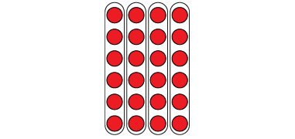  “I know that 4 × 6 = 24  and that 24 ÷ 6 = 4.  The array shows both facts.” | Uses inverse operations to solve multiplication and division problems  “I can rewrite 24 ÷ 6 = ?  as 6 × ? = 24.” | Uses known facts to determine unknown facts  “I can use the distributive property to split the multiplication into facts that I know, then add.”  5 × 9 = 5 × 5 + 5 × 4  25 + 20 = 45  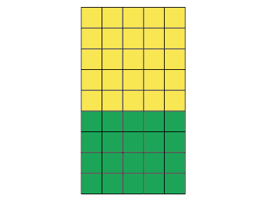 | Fluently creates and solves whole number multiplication problems with factors to 12 and related division problems  There are 96 basketballs with  the same number on each of  12 shelves.  12 × □ = 96, so 96 ÷ 12 = □  12 × 8 = 96  Or  12 × 8 = 6 × 8 + 6 × 8  = 48 + 48  = 96
Observations/Documentation

