Exploring Decimals
Relates visual representation of decimal with tenths to place value  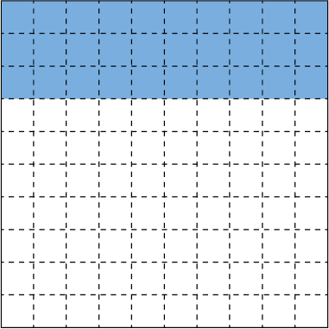  “0.3; the digit in the tenth place is 3 because there are three tenths shaded.” | Compares and orders decimals with tenths using a variety of strategies (e.g., benchmarks, grids)  “1.9 > 1.6: both decimals have 1 whole, so I compare the tenths. Nine tenths is greater than 6 tenths, so 1.9 is greater.” | Relates visual representation of decimal with hundredths to place value  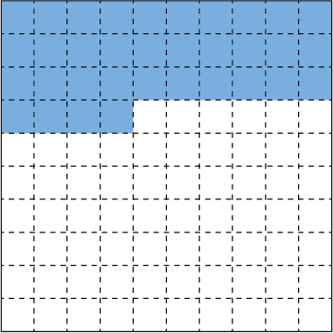  “0.34 represents 3 tenths and 4 hundredths, or 34 hundredths.” | Compares and orders decimals with tenths and/or hundredths using a variety of strategies  “1.35 > 1.19: both decimals have 1 whole, so I compare the tenths. Three tenths is greater than 1 tenth, so 1.35 is greater than 1.19.”
Observations/Documentation

Exploring Decimals (cont’d)
Rounds decimals to the nearest whole number and/or tenth  “2.29 is closer to 2.3 than to 2.2,  so I round up to 2.3.” | Expresses fractions as decimal numbers and vice versa, limited to tenths and hundredths  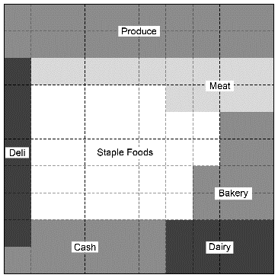  “The Dairy section covers $\frac{8}{100}$  or 0.08 of the store.” | Expresses the fraction, decimal, and percent representations for the same part-whole relationship  “I know that $\frac{2}{5}$ is the same as  four-tenths, which is the same  as 0.4, 0.40, and 40%.” | Compares percents within 100%  “45%, 89%, 27%: I know that 89% is greater than both 45% and 27%, because 8 tens is greater than both 4 tens and 2 tens.”
Observations/Documentation

