Investigating Fractions
Recognizes that equivalent fractions name the same quantity  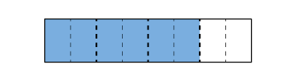  “If I partition each fourth into 2 equal parts,  I see $\frac{3}{4}$ and $\frac{6}{8}$ are the same amount.” | Identifies equivalent fractions using paper folding  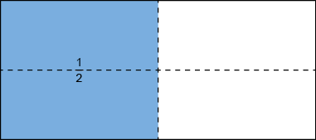  “I folded the rectangle in half and shaded one region. I folded it in half again to show $\frac{1}{2}$ = $\frac{2}{4}$.  I continued to fold the paper in half to show that  $\frac{1}{2}$ also equals $\frac{4}{8}$ and $\frac{8}{16}$.” | Names equivalent fractions by multiplying or dividing numerator and denominator by the same number  $\frac{1}{4}$: $\frac{1 × 3}{4 × 3}$ = $\frac{3}{12}$  “So, $\frac{3}{12}$ is equivalent to $\frac{1}{4}$.”
Observations/Documentation

Investigating Fractions (cont’d)
Writes a fraction in simplest form  $\frac{16}{20}$: $\frac{16 ÷ 4}{20 ÷ 4}$ = $\frac{4}{5}$  “4 and 5 have no common factors. So, $\frac{4}{5}$ is in simplest form.” | Uses fraction sense (e.g., benchmarks) to compare fractions  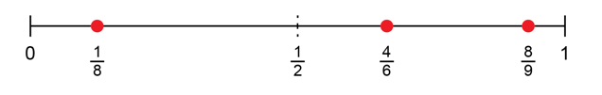  “I know $\frac{4}{6}$ is a little more than half, $\frac{8}{9}$ is pretty close to one whole, and $\frac{1}{8}$ is close to zero.” | Compares and orders fractions using a variety of strategies (e.g., equivalent fractions)  $\frac{5}{8}$, $\frac{3}{4}$, $\frac{1}{2}$: I wrote each fraction with denominator 8.  $\frac{3 × 2}{4 × 2}$ = $\frac{6}{8}$ and $\frac{1 × 4}{2 × 4}$ = $\frac{4}{8}$; so, $\frac{1}{2}$ < $\frac{5}{8}$ < $\frac{3}{4}$
Observations/Documentation

