Representing Numbers Using Place Value
Represents 5-digit number on place-value chart (decomposes in one way).  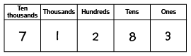  “71 283 has 7 ten-thousands, 1 thousand,  2 hundreds, 8 tens, and 3 ones.” | Represents 6-digit number on place-value chart (decomposes in one way).  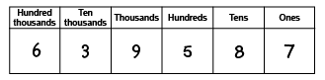  639 587: I used the digits of the number to tell me the number to write in each column.” | Uses relationships among place-value positions to read a number in more than one way.  “6 hundred-thousands,3 ten-thousands,  9 thousand, 5 hundreds, 8 tens, and 7 ones  can also be 639 thousands, 5 hundreds,  and 87 ones.”
Observations/Documentation

Representing Numbers Using Place Value (cont’d)
Represents numbers using expanded form.  “639 587 =  600 000 + 30 000 + 9000 + 500 + 80 + 7” | Rounds 6-digit numbers to various places.  “639 587 rounded to the nearest ten is 639 590, to the nearest hundred is 639 600,  to the nearest thousand is 640 000,  to the nearest 10 000 is 640 000, and to the nearest hundred thousand is 600 000.” | Represents numbers flexibly using place-value relationships.  “639 587 =  600 000 + 30 000 + 9000 + 500 + 80 + 7  Or 600 000 + 39 000 + 400 + 180 + 7  Or 639 000 + 587”
Observations/Documentation

Comparing and Ordering Quantities
Compares numbers using only the first digits.  78 543 65 987  “78 543 is greater than 65 987  because 7 is bigger than 6.” | Compares numbers with benchmarks.  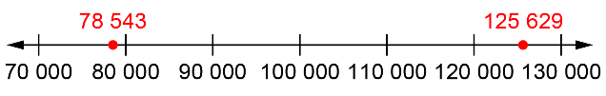  “I compared the numbers to 100 000. 78 543 is less than 100 000 and 125 629 is greater than 100 000. So, 125 629 is greater.” | Visualizes benchmarks on a number line to compare.  “I picture 125 629 farther to the right  on the line than 78 543.  So, 125 629 is greater than 78 543.”
Observations/Documentation

Comparing and Ordering Quantities (cont’d)
Uses place value understanding to compare numbers, digit by digit.  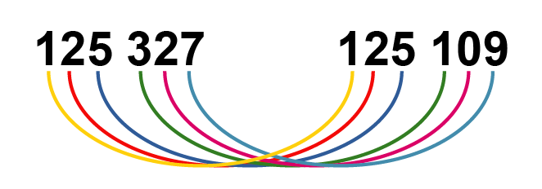  “Both start with 125 thousands. 3 hundreds is greater than 1 hundred, 2 tens is greater than 0 tens, and 7 ones is less than 9 ones. So, 125 327 is greater than 125 109.” | Compares and orders three or more numbers using a variety of strategies.  74 307 367 104 366 455  “74 307 has only 5 digits, so it’s the least.  To compare 367 104 and 366 455, I have to look at the thousands place; 7 is greater than 6,  so 367 104 is the greatest number.” | Compares numbers flexibly and records comparisons symbolically (<, =, >).  375 867 < 497 328  “Both are 6-digit numbers. The first digit tells me that 375 867 is less than 497 328.”  375 867 > 356 095  “For this pair,  I have to check the ten-thousands place.”
Observations/Documentation

