Comparing and Ordering Quantities
Compares numbers using only the first digits.  78 543 65 987  “78 543 is greater than 65 987  because 7 is bigger than 6.” | Compares numbers with benchmarks.  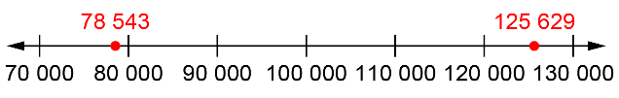  “I compared the numbers to 100 000. 78 543 is less than 100 000 and 125 629 is greater than 100 000. So, 125 629 is greater.” | Visualizes benchmarks on a number line to compare.  “I picture 125 629 farther to the right  on the line than 78 543.  So, 125 629 is greater than 78 543.”
Observations/Documentation

Comparing and Ordering Quantities (cont’d)
Uses place value understanding to compare numbers, digit by digit.  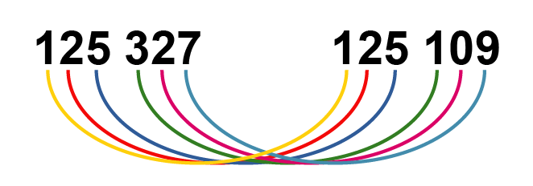  “Both start with 125 thousands. 3 hundreds is greater than 1 hundred, 2 tens is greater than 0 tens, and 7 ones is less than 9 ones. So, 125 327 is greater than 125 109.” | Compares and orders three or more numbers using a variety of strategies.  74 307 367 104 366 455  “74 307 has only 5 digits, so it’s the least.  To compare 367 104 and 366 455, I have to look at the thousands place; 7 is greater than 6,  so 367 104 is the greatest number.” | Compares numbers flexibly and records comparisons symbolically (<, =, >).  375 867 < 497 328  “Both are 6-digit numbers. The first digit tells me that 375 867 is less than 497 328.”  375 867 > 356 095  “For this pair,  I have to check the ten-thousands place.”
Observations/Documentation

