Representing Numbers Using Place Value
Represents 5-digit number on place-value chart (decomposes in one way).  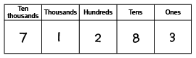  “71 283 has 7 ten-thousands, 1 thousand,  2 hundreds, 8 tens, and 3 ones.” | Represents 6-digit number on place-value chart (decomposes in one way).  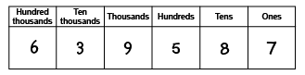  639 587: I used the digits of the number to tell me the number to write in each column.” | Uses relationships among place-value positions to read a number in more than one way.  “6 hundred-thousands,3 ten-thousands,  9 thousand, 5 hundreds, 8 tens, and 7 ones  can also be 639 thousands, 5 hundreds,  and 87 ones.”
Observations/Documentation

Representing Numbers Using Place Value (cont’d)
Represents numbers using expanded form.  “639 587 =  600 000 + 30 000 + 9000 + 500 + 80 + 7” | Rounds 6-digit numbers to various places.  “639 587 rounded to the nearest ten is 639 590, to the nearest hundred is 639 600,  to the nearest thousand is 640 000,  to the nearest 10 000 is 640 000, and to the nearest hundred thousand is 600 000.” | Represents numbers flexibly using place-value relationships.  “639 587 =  600 000 + 30 000 + 9000 + 500 + 80 + 7  Or 600 000 + 39 000 + 400 + 180 + 7  Or 639 000 + 587”
Observations/Documentation

