Exploring Duration
Tells time using fractions.  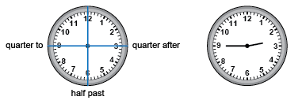  “It is quarter to three or two forty-five.” | Determines duration in minutes  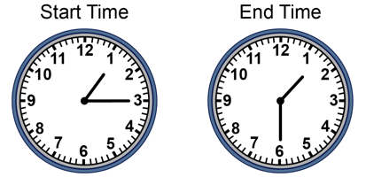  “I skip-count by 5s as the minute hand moves from 3 to 6: 5, 10, 15. The duration is 15 min.” | Relates durations in minutes to fractions of an hour  “I know there are 4 groups of 15 min in 60 min.  So, 15 min is $\frac{1}{4}$ h.”
Observations/Documentation

Exploring Duration (cont’d)
Calculates duration of an event  On Saturday, Alicia visited her grandmother  from 11:30 a.m. to 1:10 p.m.  How long did the visit last?  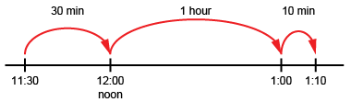  “The visit lasted 1 h 40 min or 1$\frac{2}{3}$ h.” | Compares durations using standard units  Start Time End Time Duration  12:18 p.m. 1:55 p.m. 1 h 37 min  11:23 a.m. 1:08 p.m. 1 h 45 min  “The second event lasted longer as  1 h 45 min > 1 h 37 min.” | Flexibly solves duration problems using various strategies and relationships among units  It is New Year's Eve. The clock will strike midnight in 136 min. What time is it?  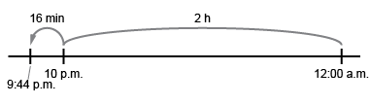  “I know 1 h = 60 min and 2 h = 120 min.  136 min = 120 min + 16 min = 2 h and 16 min. Midnight is 12:00 a.m. The time is 9:44 p.m.”
Observations/Documentation

