Investigating, Estimating, and Measuring Area
Covers with non-standard units that don’t tile to measure area  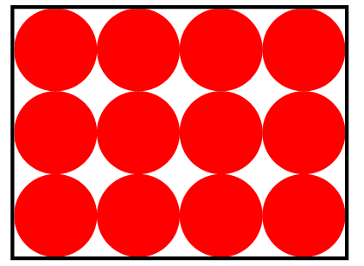  ”I covered the rectangle with counters, but there are gaps. Not all the rectangle is covered.” | Recognizes that area is measured using square units  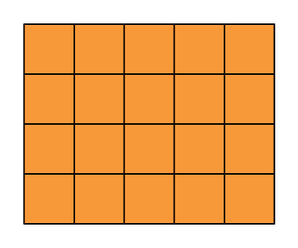  ”I covered the rectangle with square tiles and determined the area to be 20 square units.” | Tiles with square centimetres and determines area by counting squares  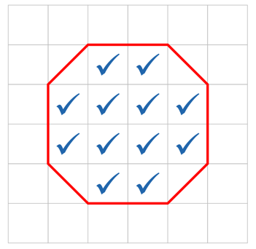  “I covered the octagon with square centimetres and counted 12 whole squares. So, the area is about 12 square centimetres.” | Uses partial units to get more precise measure  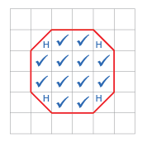  “I counted squares on the 1-cm grid: 12 whole squares and 4 half squares, which make 2 whole squares, so the area is 14 cm².”
Observations/Documentation

Investigating, Estimating, and Measuring Area (cont’d)
Uses referents to estimate area, then measures to check  “I used my fingernail as a referent  for 1 cm². I estimated the area of Shape A to be 14 cm². Then I measured to check and the area was 16 cm².” | Uses row and column structure of an array to determine area of a rectangle  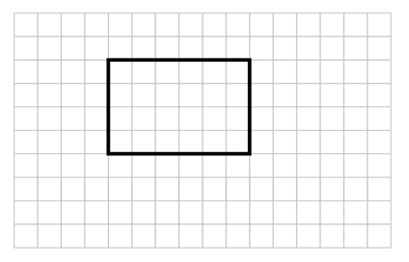  “I traced the rectangle on a 1-cm grid where each square represents 1 cm². The rectangle forms an array with 4 rows of 6 squares:  4 × 6 = 24; the area of the rectangle is 24 cm². | Constructs different rectangles for a given area (square centimetres)  Area of rectangle = 16 cm²  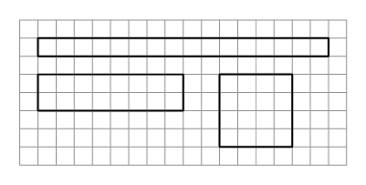  “I constructed 3 different rectangles: A square with side length 4 cm:  4 cm × 4 cm = 16 cm².  A 2-cm by 8-cm rectangle:  2 cm × 8 cm = 16 cm^{2.}  A 1-cm by 16-cm rectangle:  1 cm × 16 cm = 16 cm².” | Flexibly determines the area of shapes, including rectangles, and solves problems  A baseball ticket has an area of 75 cm². The ticket is 5 cm wide.  How long is it?  “I know A = l × w, so I solved the equation 75 = l × 5.  I know 15 × 5 = 75, so the ticket is 15 cm long.”
Observations/Documentation

