Investigating Area in First Nations, Métis, and Inuit Designs
Describes materials used in some First Nations, Métis, and Inuit designs  “I see leather, birch bark, beads, fur,  and porcupine quills.” | Explains how designers might come up with their designs  “They might have got ideas from nature, symbols, ceremony, culture, stories, and family.” | Understands how the gathering of materials shows respect of animals and the natural world  “When gathering materials, thanks is offered to  the animal or natural object that will be used.”
Observations/Documentation

Investigating Area in First Nations, Métis, and Inuit Designs (cont’d)
Describes how the use of materials in designs shows respect for animals and the natural world  “All parts of the animal are used; for example,  for food, clothing, ceremony, shelter.” | Describes various types of traditional styles of design  “Different styles include bead embroidery,  bead stringing, off-loom bead weaving, braiding with beads, and loom beading.” | Shows that rearranging beads on a loom template does not change the number of beads needed to complete a design  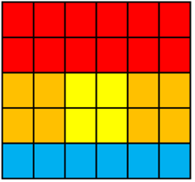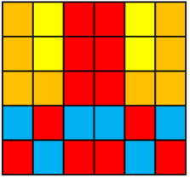  “They use the same number of each  colour of bead.”
Observations/Documentation

