Exploring Polygons and Prisms
Recognizes that a close approximation of a polygon is not the same as a polygon  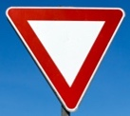  “The Yield sign approximates a triangle, but it isn’t a triangle because the corners are rounded.” | Identifies relationships between sides of a polygon, and faces of a prism by measuring  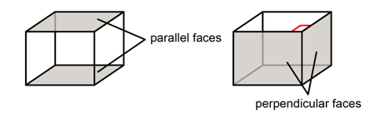  “A rectangular prism has opposite faces parallel and adjacent faces perpendicular.” | Recognizes and names different quadrilaterals  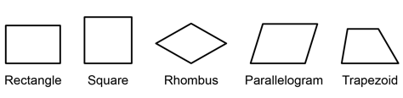  “These are all quadrilaterals because they have 4 sides. Each one has a special name.” | Identifies and describes geometric properties of different quadrilaterals  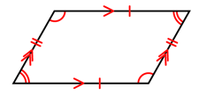  “A parallelogram has opposite sides equal and parallel, opposite angles equal, and adjacent angles supplementary.”
Observations/Documentation

Exploring Polygons and Prisms (cont’d)
Classifies quadrilaterals in a hierarchy and names them in different ways  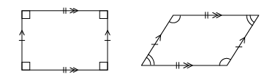  “A rectangle is a parallelogram because it has opposite sides equal and parallel, and opposite angles equal.” | Describes various triangles by side length  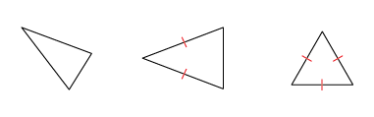  “I know the first is scalene, the second is isosceles, and the third is equilateral by looking at the number of equal sides.” | Classifies triangles using geometric properties related to angles  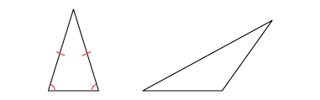  “The first triangle is an acute triangle because it has all acute angles. The second triangle is an obtuse triangle because it has an obtuse angle.” | Verifies that geometric properties of a polygon do not change after a transformation  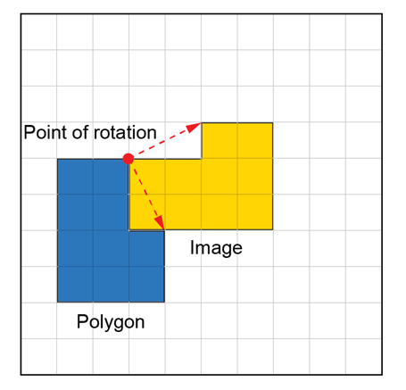  “After a rotation, the side lengths and angle measures of the polygon don’t change.”
Observations/Documentation

Classifying and Measuring Angles
Identifies and compares different types of angles using the benchmark of 90°  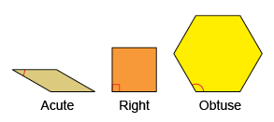  “This is an acute angle because  it is less than 90$°.$  This is an obtuse angle because  it is greater than 90°.” | Compares, measures, and classifies angles using a protractor  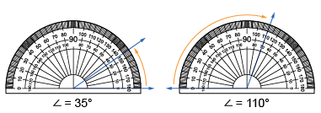  “I can use the protractor to compare and measure angles. The two scales on the protractor make it easier to measure acute and obtuse angles.” | Estimates, compares, and measures angles using standard units and benchmarks  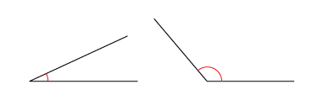  “The first angle is about halfway between 0° and 45°, so it is about 25°. The second angle is less than halfway between 90° and 180°, so it’s about 130°.” | Relates angles of 90°, 180°, 270°, and 360° to fractions of a circle  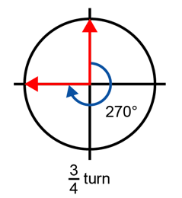  “A right angle, or 90°, represents a  $\frac{1}{4}$ turn; 180° is a $\frac{1}{2}$ turn, 270° is a $\frac{3}{4}$ turn, and 360° is a full turn.”
Observations/Documentation

