Classifying and Measuring Angles
Identifies and compares different types of angles using the benchmark of 90°  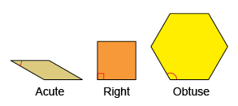  “This is an acute angle because  it is less than 90$°.$  This is an obtuse angle because  it is greater than 90°.” | Compares, measures, and classifies angles using a protractor  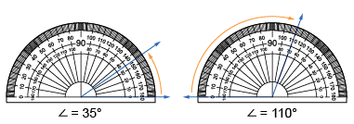  “I can use the protractor to compare and measure angles. The two scales on the protractor make it easier to measure acute and obtuse angles.” | Estimates, compares, and measures angles using standard units and benchmarks  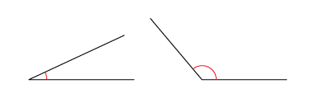  “The first angle is about halfway between 0° and 45°, so it is about 25°. The second angle is less than halfway between 90° and 180°, so it’s about 130°.” | Relates angles of 90°, 180°, 270°, and 360° to fractions of a circle  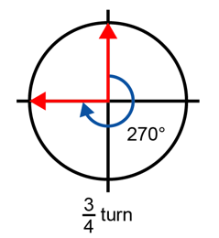  “A right angle, or 90°, represents a  $\frac{1}{4}$ turn; 180° is a $\frac{1}{2}$ turn, 270° is a $\frac{3}{4}$ turn, and 360° is a full turn.”
Observations/Documentation

