Describing and Representing Data
Describes given data using frequency counts.  Students in three Grade 4 classes were asked to choose  their favourite pizza.  “30 students chose Pepperoni as their favourite pizza. Only 6 students chose Vegan.” | Represents data using a pictograph or dot plot using many-to-one correspondence.  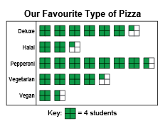  “The key is 1 square  represents 4 students.  For 17 students: 17 ÷ 4 = 4 R1,  so I drew 4 full squares,  and one-fourth of another square.” | Represents data using a bar graph using many-to-one correspondence.  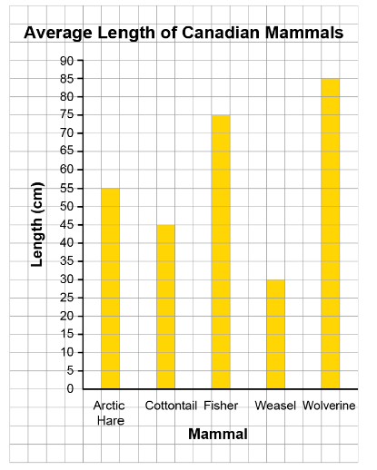  “I used the scale 1 square = 5 cm to represent animal lengths.  All of the lengths were divisible by 5, so I divided each animal’s length by 5 to find the number of squares  in each bar.” | Flexibly creates representations to show data using many-to-one correspondence.  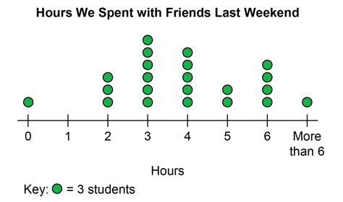  “I used a key of 1 dot = 3 students because all numbers are multiples of 3 and are in the skip-counting by 3s sequence. Other students will find it easy to interpret.”
Observations/Documentation

Interpreting Data and Making Informed Decisions
Draws conclusions based on data presented.  “A sweater uses about 6 times as many bottles as a t-shirt.” | Uses inferences to make predictions about future events.  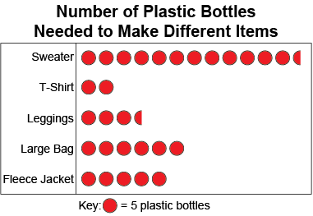  “More t-shirts could be made and sold with the fewest number of plastic bottles. I predict it would take less time to collect bottles and more money could be made. I think t-shirts should be sold for a fundraiser.” | Interprets the results of data presented graphically.  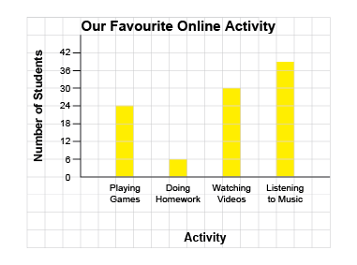  "The bar graphs shows 99 students took the survey: 24 + 6 + 30 + 39 = 99. 15 more students listen to music than play games on-line.” | Analyzes and interprets data to make convincing arguments and informed decisions.  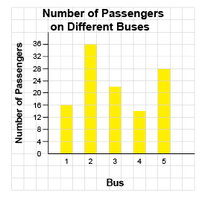  “Since most passengers are on bus number 2, the bus company might add another bus to that route. The company could take one of the schedule times from bus number 4 and give it to bus 2 because it has the fewest number of passengers. It is important to meet the needs of the passengers.”
Observations/Documentation

