Patterning and Algebra
Unit 2 Line Master 1
Make a Match!

Picture | Statement | Expression or Equation
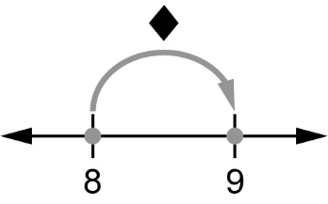 | 8 plus a number  is equal to 9
 | 2 times a number
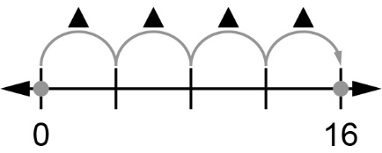 | 4 times a number  is equal to 16
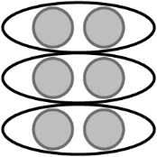 | 6 divided by  a number is  equal to 2
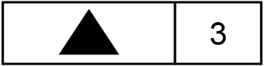 | A number plus 3
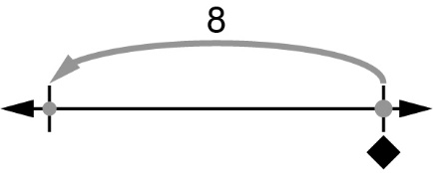 | A number minus 8

