Close to Perfect!

**Number**

**Unit 2 Line Master 4a**

1. Cut out the square root cards.   
Place each card in the bin that best estimates its square root.

2. For the four blank cards, write a number under each square root sign   
so that one card fits in each bin.

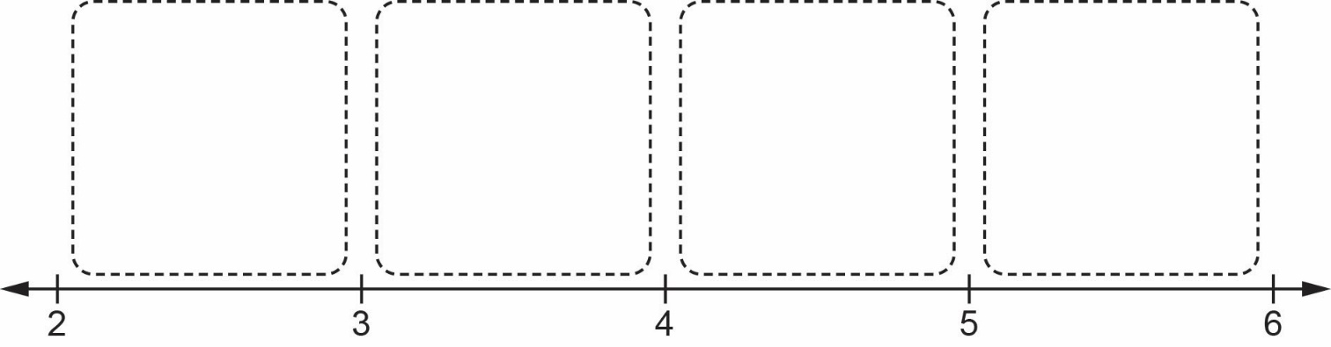

|  |  |  |  |
| --- | --- | --- | --- |
| $$\sqrt{32}$$ | $$\sqrt{18}$$ | $$\sqrt{10}$$ | $$\sqrt{5}$$ |
| $$\sqrt{7.8}$$ | $$\sqrt{31.86}$$ | $$\sqrt{23.2}$$ | $$\sqrt{11.8}$$ |
| $$\sqrt{19\frac{1}{3}}$$ | $$\sqrt{\frac{19}{2}}$$ | $$\sqrt{\frac{23}{5}}$$ | $$\sqrt{27\frac{5}{8}}$$ |
|  |  |  |  |

Close to Perfect! (cont’d)

**Number**

**Unit 2 Line Master 4b**

3. For each square root below:

a) Estimate its value to the nearest whole number.   
Explain your reasoning.

b) Estimate its value to the nearest tenth.   
Explain your reasoning.

c) Check your answer using a calculator.

$\sqrt{32}$ $\sqrt{18}$ $\sqrt{23.2}$ $\sqrt{19\frac{1}{3}}$