*The Sierpinski Triangle* Answers

**Number**

**Unit 1 Line Master 4b**

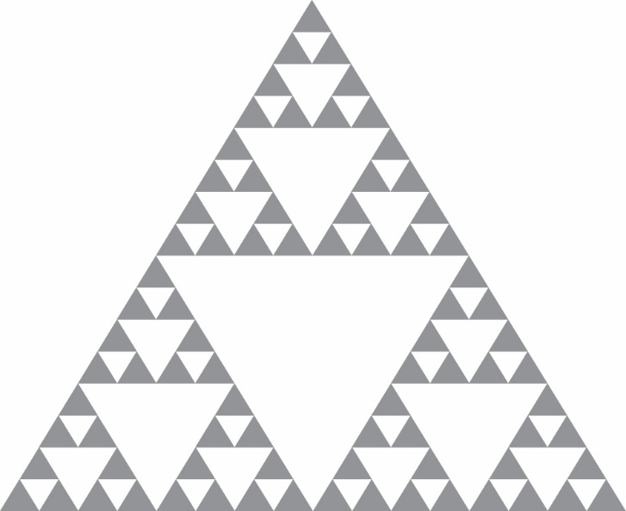1. a)

b) There will be 243 grey triangles. The sequence is 1, 3, 9, 27, 81, …; the number of grey triangles triples each time, and 81 × 3 = 243.

c) The sequence of white triangles is 0, 1, 4, 13, 40, …. Each term is the number of white triangles in the previous term plus the number of grey triangles in the previous term. For example: Number of white triangles in term 4:  
Number of white triangles in term 3: 4  
Number of grey triangles in term 3: 9  
9 + 4 = 13