Limits of Sequences

**Number**

**Unit 1 Line Master 3a**

Consider each sequence of numbers. What is the limit?  
How can you tell from the table? From the graph?

a)

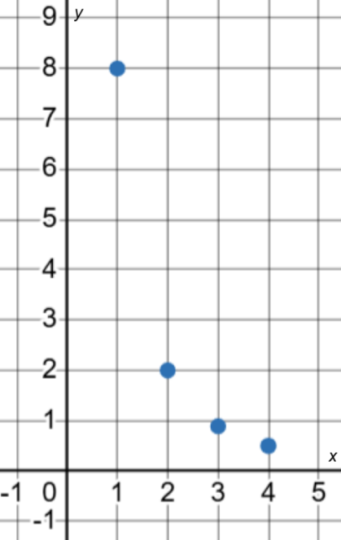 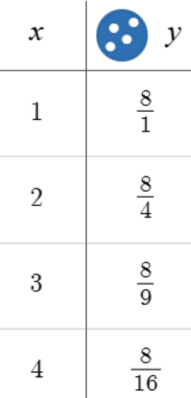

b)

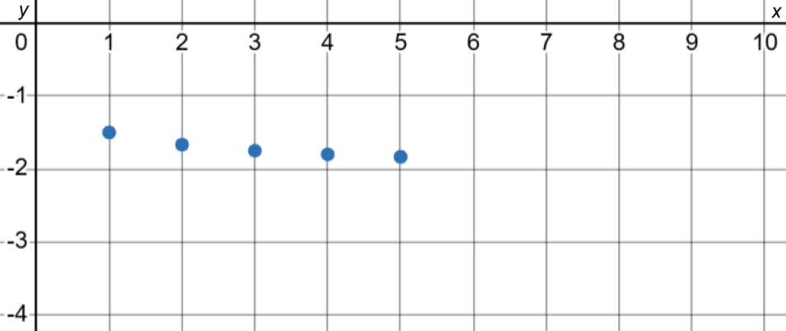 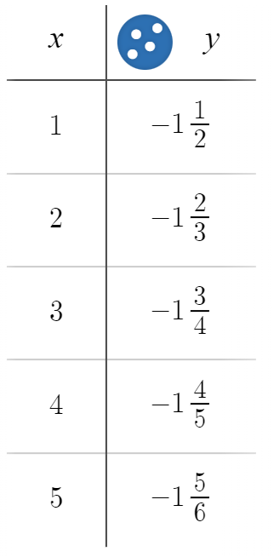

Limits of Sequences (cont’d)

**Number**

**Unit 1 Line Master 3b**

c)

