***Exploring Volume with Coding* Answers**

**Measurement**

**Unit 3 Line Master 2g**

**Part A: Volume of a Prism**

What happens to the volume of a prism when its height is doubled?

**About the Code:** Different computer languages might use different keyboard characters for math calculations, but all languages follow the order of operations (BEDMAS) in their calculations. In Python, one asterisk (*) is used for multiplication.

1. Copy this exact code into a Python console, such as [Google Colab](https://colab.research.google.com/) or <https://cscircles.cemc.uwaterloo.ca/console/> to calculate the volume of a rectangular based prism as its height doubles each time.

length = 5

width = 5

height = 10

print ("Height  Prism Volume")

for i in range (0,10):

  baseArea = length * width

  prismVolume = round(baseArea * height)

  print (height, "\t", prismVolume)

  height = height * 2

**About the Code:**

* The values for the length and width both start at 5, and the value for height   
  starts at 10.
* The title for each column of data that will be output are: **Height, Prism Volume**.
* A *“for”* loopis used to repeat the indented code below it 10 times.

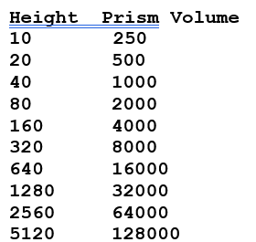Select *Run* to execute the code.

1. What does the output look like?
2. What happens to the volume of a prism each   
    time the height is doubled?

**Each time the height doubles,   
 the volume of the prism doubles in value.**

***Exploring Volume with Coding* Answers** (cont’d)

**Measurement**

**Unit 3 Line Master 2h**

**Part B: Volume of a Pyramid**

What happens to the volume of a pyramid as its height is doubled?

Let’s alter the code from Part A so that it displays the volume of a pyramid   
with the same base and starting height as the prism.   
Recall that the volume of a pyramid is $\frac{1}{3}$ the volume of a prism with the same base   
and height. So, you just need to divide the volume from Part A by 3.

1. Alter the code for the prism in Part A as shown below.

length = 5

width = 5

height = 10

print ("Height  Pyramid Volume")

for i in range (0,10):

  baseArea = length * width

  pyramidVolume = round((baseArea * height)/3)

  print (height, "\t", pyramidVolume)

  height = height * 2

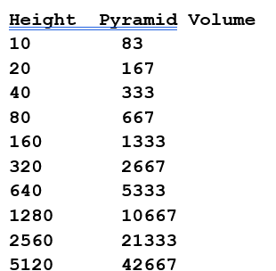

1. What does the output look like?
2. What happens to the volume of the pyramid each time the height is doubled?

**Each time the height doubles, the volume of the pyramid doubles.   
Note that since the volumes are rounded, they may appear to be slightly off, but they will be approximately twice the previous value.**

***Exploring Volume with Coding* Answers** (cont’d)

**Measurement**

**Unit 3 Line Master 2i**

**Part C: Volume of a Cylinder**

What happens to the volume of a cylinder as its height is doubled?

Alter the code again to determine the volume of a cylinder.

Recall that the volume of a cylinder, like the volume of a prism, is:   
area of base × height.

The area of the base of a cylinder is the area of a circle:

Area of a circle = π*r*2

**About the Code:**

In Python, two asterisks (**) are used for an exponent.

1. Copy this exact code to calculate the volume of a cylinder as its height doubles   
   each time.

radius = 5

height = 10

print ("Height  Cylinder Volume")

for i in range (0,10):

  baseArea = 3.14 * radius**2

  volumeCylinder = round(baseArea * height)

  print (height,"\t", volumeCylinder)

  height = height * 2

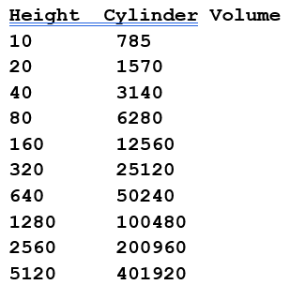

1. What does the output look like?
2. What happens to the volume of the cylinder each time the height is doubled?

**Each time the height doubles, the volume of the cylinder doubles.**

***Exploring Volume with Coding* Answers** (cont’d)

**Measurement**

**Unit 3 Line Master 2j**

What happens to the volume of a cylinder as its radius is doubled?

1. Alter the code in question 3 so that the radius doubles rather than the height:

radius = 5

height = 10

print ("Height  Cylinder Volume")

for i in range (0,10):

  baseArea = 3.14 * radius**2

  volumeCylinder = round(baseArea * height)

  print (height,"\t", volumeCylinder)

  radius = radius * 2

1. Before running the code, predict what will happen to the volume of the cylinder   
   as the radius is doubled.

**For example: I think the volume will increase 4 times since the area of a circle is π*r*2 and the radius is doubling.**

1. 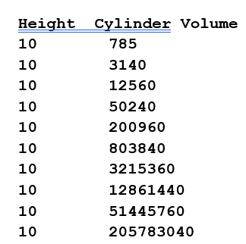Execute the code. What does the output look like?
2. What happens to the volume of the cylinder each time the radius doubles?   
   Why does this happen?

**The volume of the cylinder is 4 times the previous value each time   
the radius is doubled. This is because the radius is squared in the formula   
for the area of the base.**

***Exploring Volume with Coding* Answers** (cont’d)

**Measurement**

**Unit 3 Line Master 2k**

**Part D: Volume of a Cone**

Recall that the volume of a cone is $\frac{1}{3}$ the volume of a cylinder with the same base   
and height.

1. Alter the code in Part C to see what happens to the volume of a cone   
   when its radius is doubled.

radius = 5

height = 10

print ("Height  Cone Volume")

for i in range (0,10):

  baseArea = 3.14 * radius**2

  volumeCone = round((baseArea * height)/3)

  print (height,"\t", volumeCone)

  radius = radius * 2

1. What does the output look like?

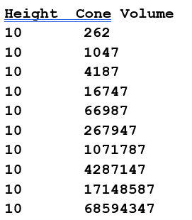

1. What happens to the volume of a cone as the radius is doubled?

**The volume of the cone is 4 times the previous value each time the radius is doubled. This is because the radius is squared in the formula for the area of the base.**

***Exploring Volume with Coding* Answers** (cont’d)

**Measurement**

**Unit 3 Line Master 2l**

**Reflect and Connect**

1. Predict what will happen to the volume of a prism or pyramid   
   when its height is tripled.

**The volume of the prism or pyramid will triple.**

1. Predict what will happen to the volume of a cylinder or cone   
   when its height is tripled.

**The volume of the cylinder or cone will triple.**

1. Predict what will happen to the volume of a cylinder or cone   
   when its radius is tripled.

**The volume of the cylinder or cone will be 9 times the previous value.**

1. Alter the code to explore how changing dimensions affects the area or volume   
   of other 2-D shapes and 3-D objects.

**For example: The area of a triangle as its height doubles:**

base = 5

height = 5

print ("Height  Triangle Area")

for i in range (0,10):

  area = (base * height)/2

  print (height, '\t', area)

  height = height * 2

**The volume of a triangular prism as its height doubles:**

base = 5

height = 5

length = 10

print ("Height  Prism Volume")

for i in range (0,10):

  baseArea = (base * height)/2

  prismVolume = baseArea * length

  print (height, '\t', prismVolume)

  height = height * 2