Scale Map of Canada
Measurement
Unit 2 Line Master 5

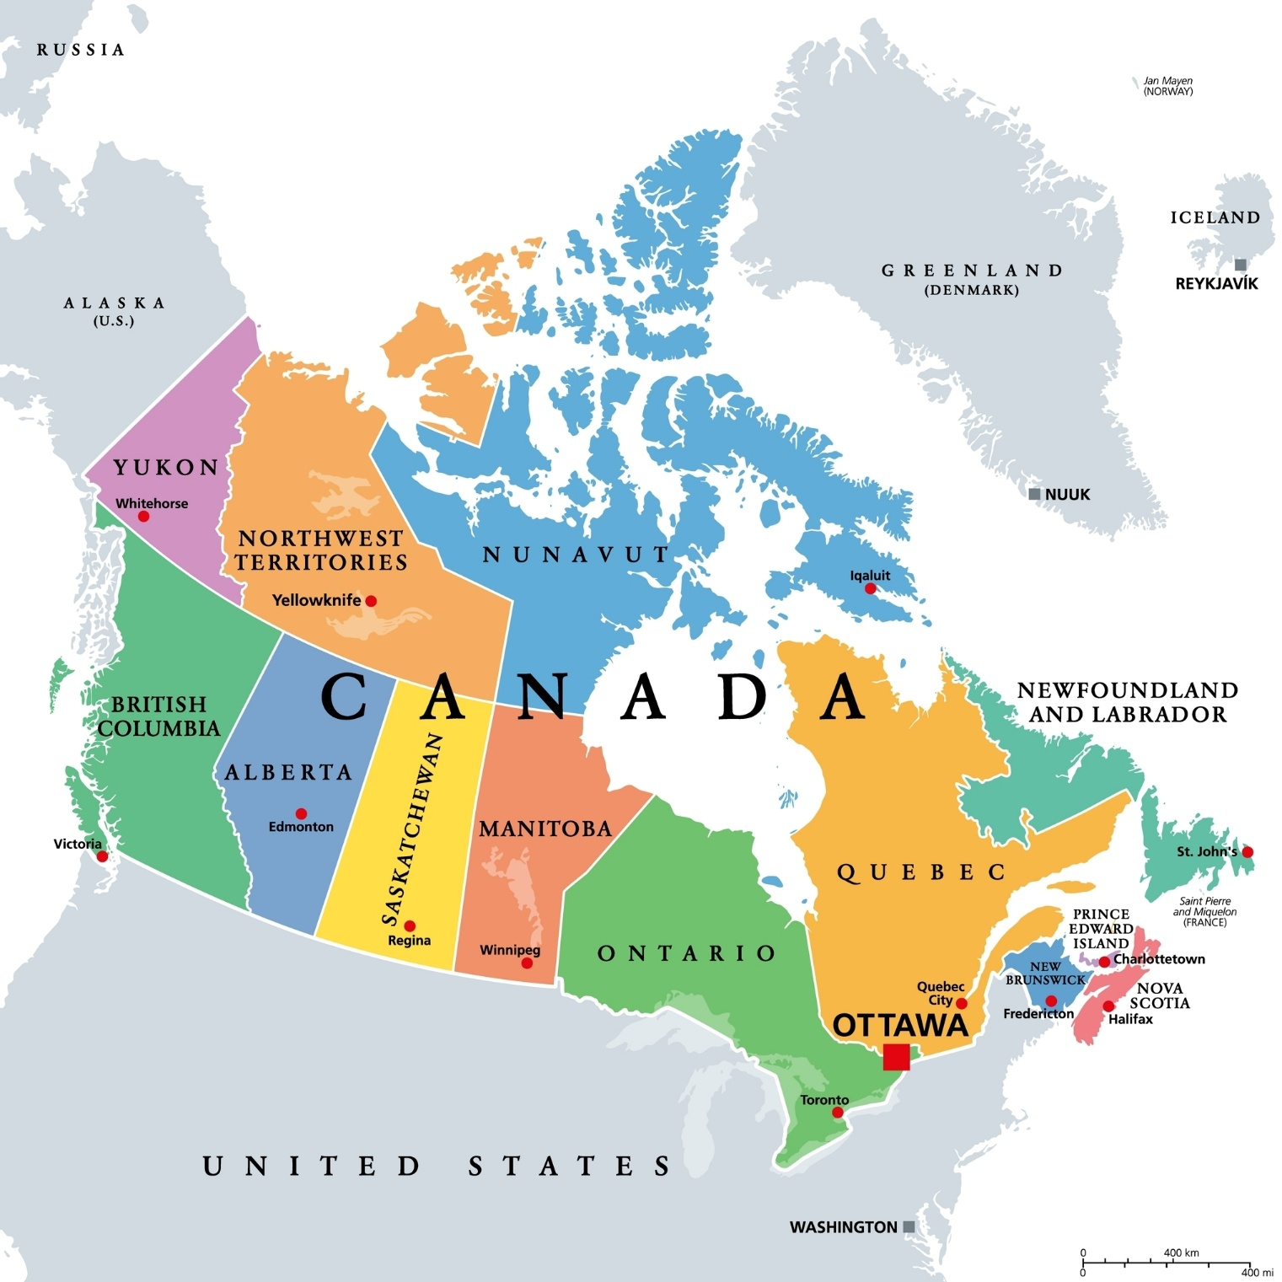
0 km |  | 800 km
1600 km

