Are We Similar?

**Measurement**

**Unit 2 Line Master 3a**

1. 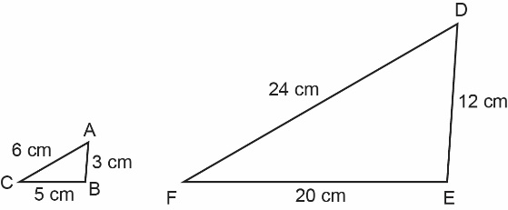For each pair of polygons, identify whether they are similar. If they are similar, identify whether the second polygon is a reduction or enlargement of the first polygon and by what scale factor.  
   Explain your reasoning.  
   a)

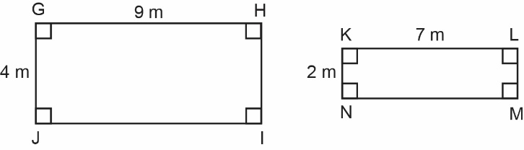b)

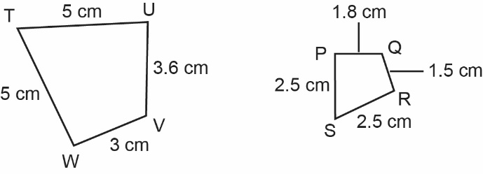c)

Are We Similar? (cont’d)

**Measurement**

**Unit 2 Line Master 3b**

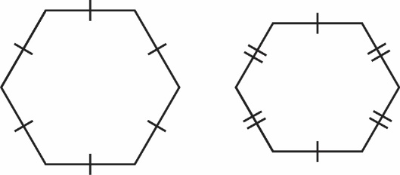d)

1. 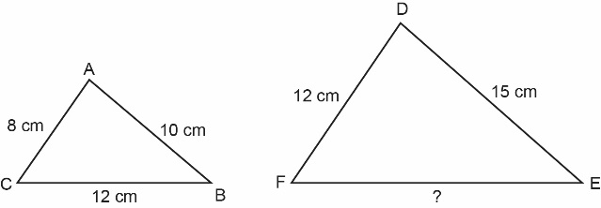For each pair of similar polygons, determine the length of the unknown side.   
     
   a)

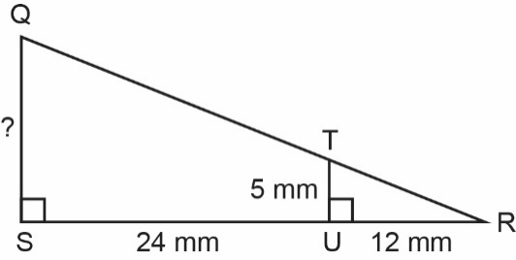

b)

Are We Similar? (cont’d)

**Measurement**

**Unit 2 Line Master 3c**

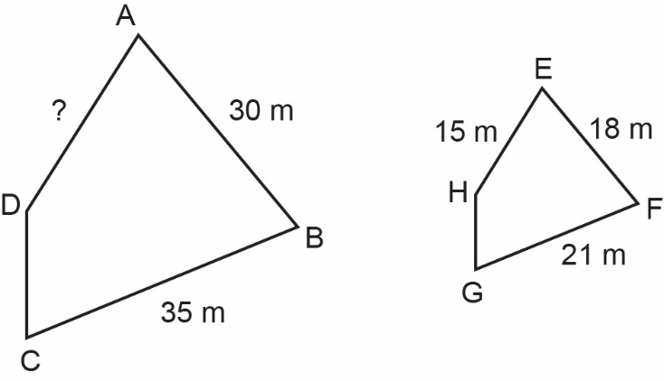c)

1. Draw a triangle that is similar to ∆ABC.   
   Draw a triangle that is not similar to ∆ABC.   
   Explain your reasoning.

