Geometric Properties
and Relationships
Geometry
Unit 1 Line Master 7

Angles with Parallel and Intersecting Lines  - Corresponding angles are congruent.  - Alternate angles are congruent.  - Opposite angles are congruent.  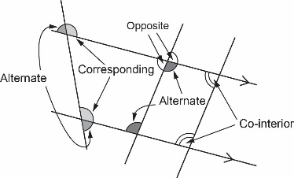  - Co-interior angles are supplementary. | Sum of Interior Angles in a Polygon  A polygon of n sides can be divided into  (n – 2) triangles.  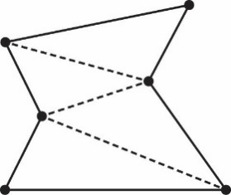  So, the sum of the interior angles is  (n – 2) × 180°.
Sum of Exterior Angles in a Polygon  The sum of the exterior angles of a polygon is 360°.  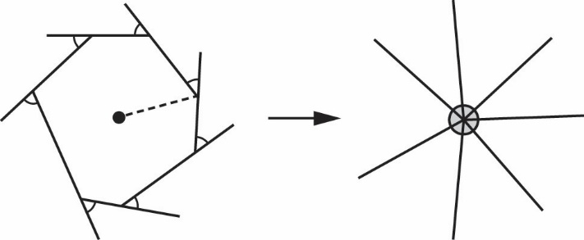 | Side Lengths of a Triangle  The sum of any two sides of a triangle is always greater than the length of the third side.  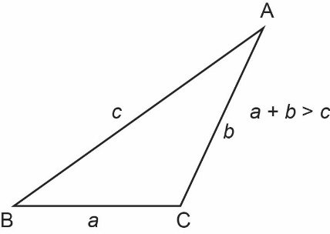
Angles and Side Lengths in a Triangle  The relative lengths of the sides are the same as the relative measures of the angles to which they are opposite.  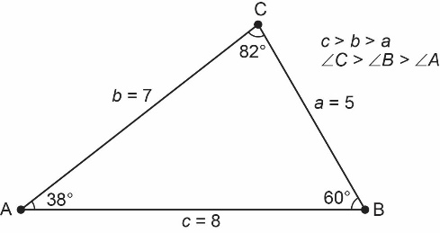 | Perpendicular Bisector in a Right Triangle  A perpendicular bisector of a leg in a right triangle bisects the hypotenuse.  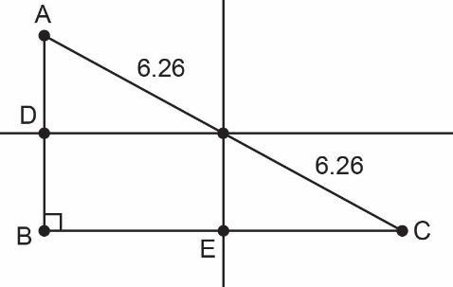
Angle Bisector in a Triangle  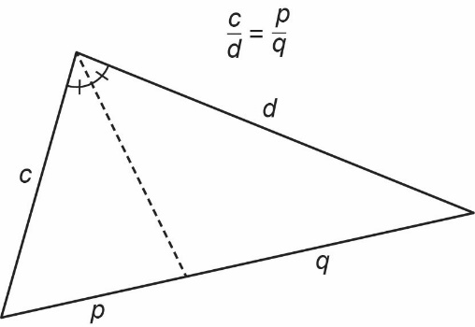 | Median of a Triangle  