Investigating Geometric Relationships

**Geometry**

**Unit 1 Line Master 6a**

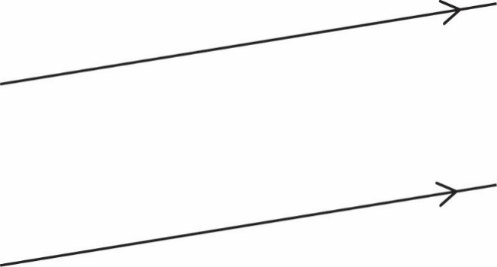**Angles with Parallel and Intersecting Lines**

The given lines are parallel. Draw a line (*transversal*) that crosses the parallel lines.

Which angles do you think are congruent? Measure these angles to confirm.   
What angle relationships did you discover?

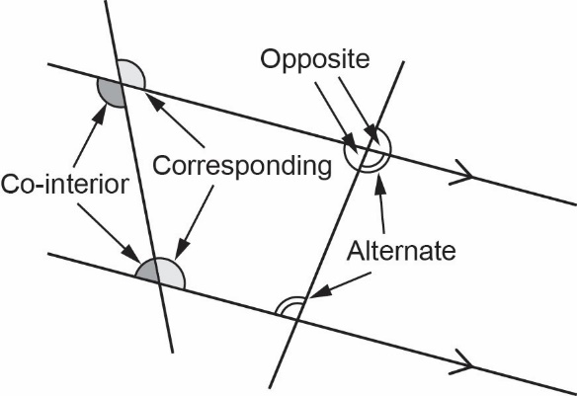When a transversal crosses parallel lines,   
there are several pairs of angles that have   
named relationships.  
  
Which pairs of angles are congruent? Which pairs   
of angles are supplementary?

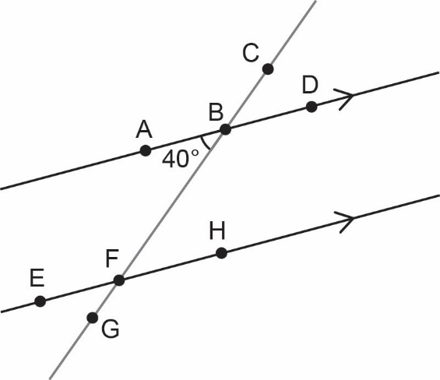Determine the unknown angles. Justify how you know   
(e.g., corresponding angles).   
Relate each reason to the given $∠ABF$.

|  |  |  |
| --- | --- | --- |
| **Angle** | **Measure** | **Reason** |
| ABF | 40° | given |
| EFG |  |  |
| CBD |  |  |
| BFH |  |  |
| FBD |  |  |
| EFB |  |  |

Investigating Geometric Relationships (cont’d)

**Geometry**

**Unit 1 Line Master 6b**

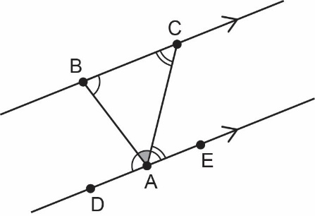How can you use parallel lines to prove that the sum of   
the interior angles in a triangle is 180°?

**Sum of Interior Angles in a Polygon**

To determine the sum of the interior angles in a polygon, you can divide the polygon   
into triangles. The sum will be the number of triangles × 180°.

Draw a polygon and divide it into triangles. How does the number of triangles   
relate to the number of sides of the polygon?

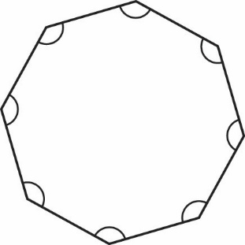What is the measure of each angle in a regular octagon?

Investigating Geometric Relationships (cont’d)

**Geometry**

**Unit 1 Line Master 6c**

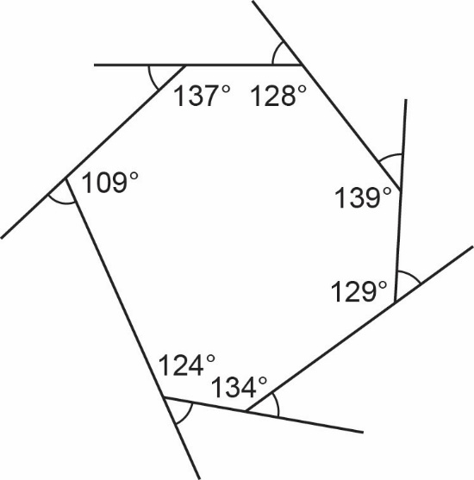**Sum of Exterior Angles of a Polygon**

The interior angles of a heptagon are shown.   
  
What is the sum of its exterior angles?

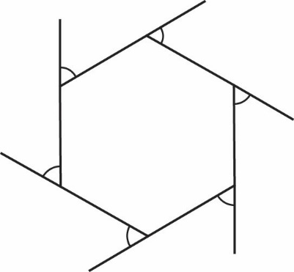What is the measure of each exterior angle of a regular hexagon?

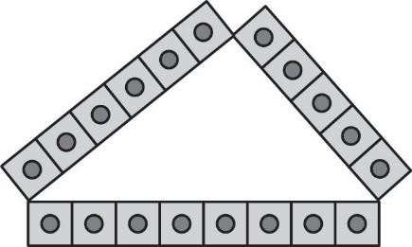**Side Lengths of a Triangle**

Given any three side lengths, is it always possible   
to make a triangle?

Use Relational rods of various lengths or linking cubes   
to try to make a variety of triangles.   
What do you notice? When is a triangle possible?

A triangle has side lengths 5 and 8.

* 1. What is the shortest possible integer length of the third side?

* 1. What is the longest possible integer length of the third side?

1. Investigating Geometric Relationships (cont’d)

**Geometry**

**Unit 1 Line Master 6d**

**Angles and Side Lengths in a Triangle**

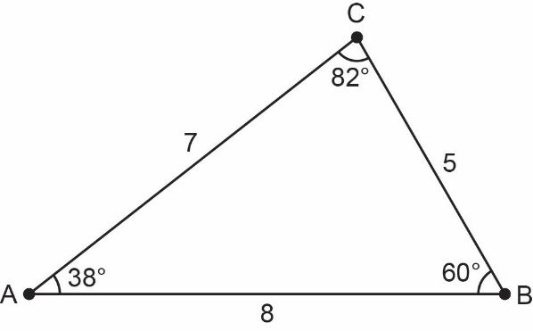How do the relative side lengths of the triangle relate   
to the relative size of the angles?

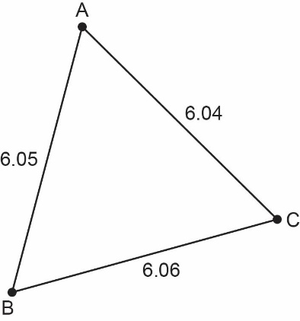What is the largest angle of the triangle?   
How do you know?

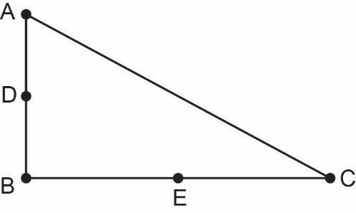**Perpendicular Bisector in a Right Triangle**

Points D and E are midpoints on the legs of this right triangle.

Construct the perpendicular bisectors   
through points D and E.

What do you notice about the hypotenuse?

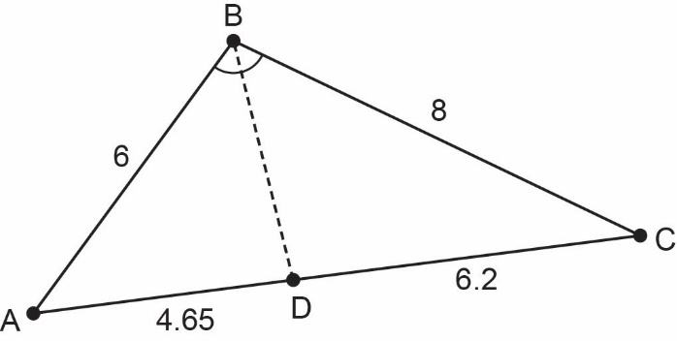

**Angle Bisector in a Triangle**

$\overline{BD}$ bisects $∠ABC$. Calculate the ratios $\frac{AB}{CB}$ and $\frac{AD}{CD}$. What do you notice?

1. Investigating Geometric Relationships (cont’d)

**Geometry**

**Unit 1 Line Master 6e**

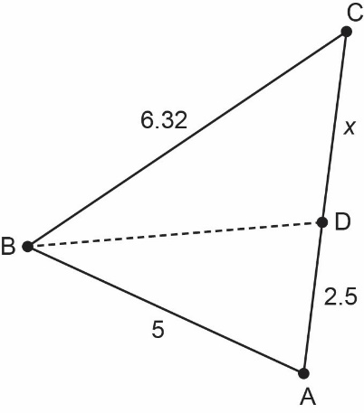 $\overline{BD}$ 
 bisects $∠ABC$. What is the length of $\overline{CD}$?

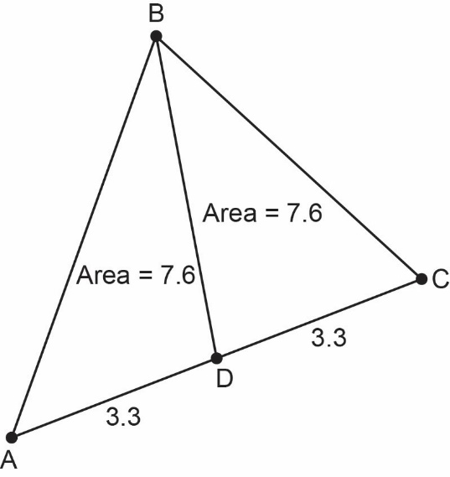**Median of a Triangle**

$\overline{BD}$ is a *median*, meaning it bisects $\overline{AC}$.

What does a median do to the area of a triangle?

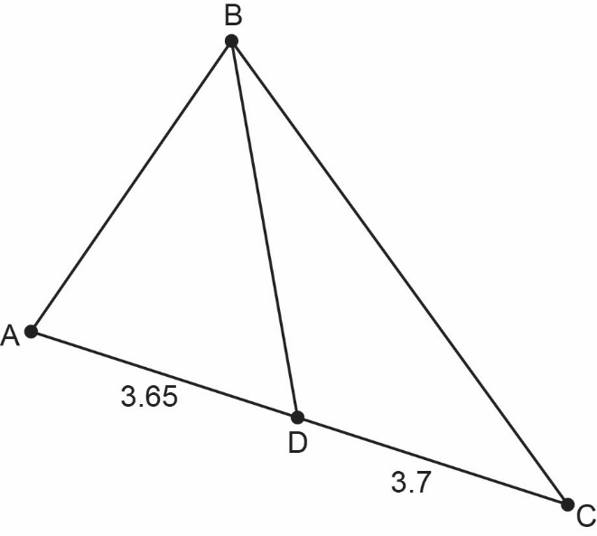

Which triangle has the greater area, $∆ABD$ 
 or $∆CBD$? How do you know?