Investigating Circle Properties   
 and Constructions

**Geometry**

**Unit 1 Line Master 5a**

**Exploring Chords in a Circle**

* Use a compass to construct a circle on paper or tracing paper. Label the centre C.
* Construct chord $\overline{AB}$ that is not a diameter.
* Fold the circle so that point A coincides with point B.
* What do you notice about the fold?

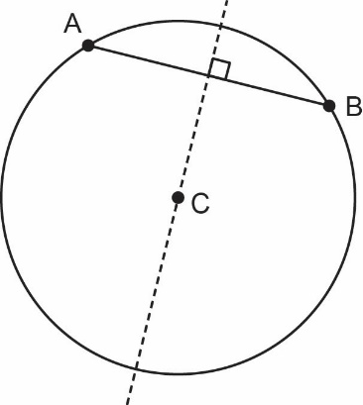

**Application**

|  |  |
| --- | --- |
| a) The radius of this circle is 9.  The length of chord $\overline{AB}$ is 12.  How far is the chord from the centre  of the circle?  (i.e., What is the length of $\overline{CD}$?)  (Answer to the nearest tenth) | b) The radius of this circle is 6.  The length of $\overline{CD}$ is 3.  What is the length of chord $\overline{AB}$?  (Answer to the nearest tenth) |

Investigating Circle Properties   
 and Constructions (cont’d)

**Geometry**

**Unit 1 Line Master 5b**

**Exploring Angles and Arcs**

* Use a compass to construct a circle. Label the centre C.
* Place points A and B on the circle to create minor arc $\overset{⏜}{AB}$.
* Add points D, E, and F on the circle (not between the minor arc AB) and join segments   
  to create inscribed angles $∠ADB$, $∠AEB$, and $∠AFB$.
* Use a protractor to measure these angles. What do you notice?
* 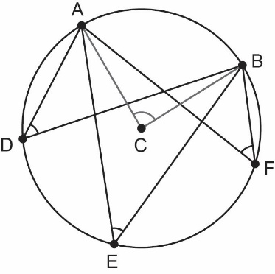Construct and measure central angle $∠ACB$. What do you notice?

**Application**

|  |  |
| --- | --- |
| a) Point C is the centre of the circle.  Determine the measure of $∠ADB$. | b) Point C is the centre of the circle.  Determine the measure of $∠CAB.$ |

Investigating Circle Properties   
 and Constructions (cont’d)

**Geometry**

**Unit 1 Line Master 5c**

**Exploring Tangents to a Circle**

* Use a compass to construct a circle. Label the centre C.
* Construct a radius $\overline{AC}$.
* Use a protractor to construct 90° angles on both sides of the radius at point A,   
  and extend the line.
* 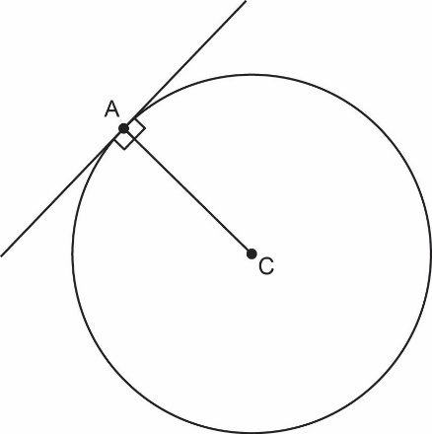What do you notice about the line in relation to the circle?

**Application**

|  |  |
| --- | --- |
| a) $\overline{AB}$ is tangent to the circle at Point A.  The radius of the circle is 12,  and AB = 16.  What is the length of $\overline{BC}$? | b) $\overline{BD}$ is tangent to the circle at Point A.  The radius of the circle is 3.  If BC = 4.5 and DC = 3.5,  what is the length of $\overline{BD}$?  (Answer to the nearest tenth) |