ExploringLinear and   
 Rotational Symmetry

**Geometry**

**Unit 1 Line Master 1a**

* Classify each shape below by the number of lines of symmetry.
* Identify any rotational symmetry in the shapes and state the order   
  and angle of rotation.

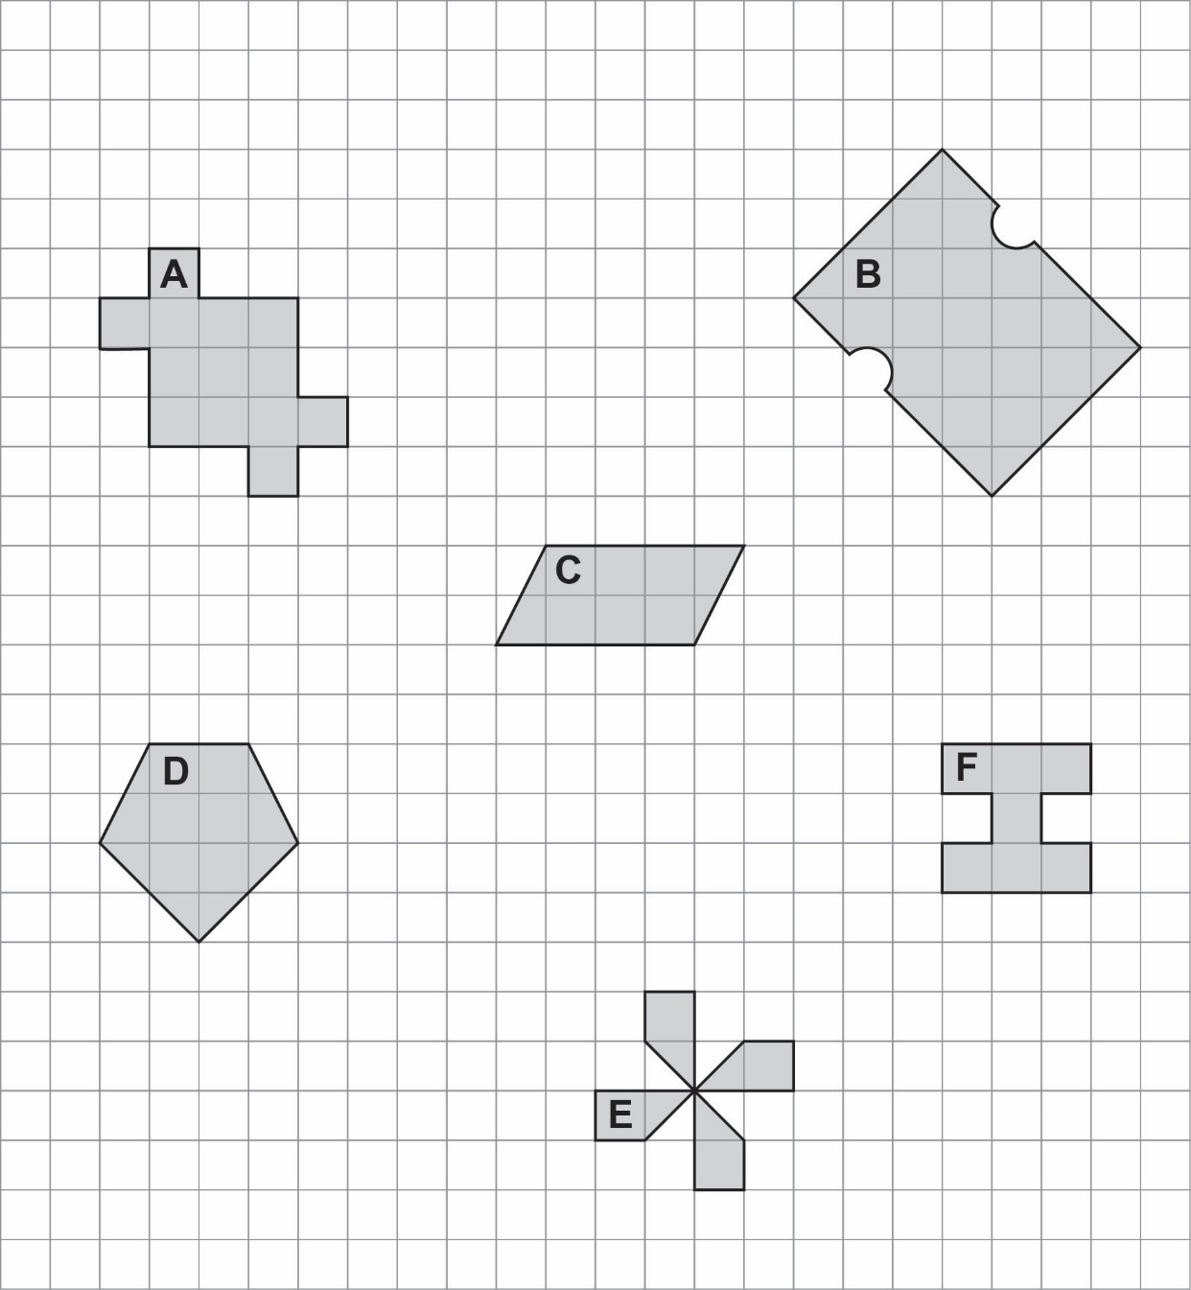

ExploringLinear and   
 Rotational Symmetry (cont’d)

**Geometry**

**Unit 1 Line Master 1b**

