**The Well-Chosen Average**

**Data Management**

**Unit 1 Line Master 14**

***(adapted from “How to lie with statistics” by Darrell Huff, 1954)***

You are looking to buy a new house in a nice neighbourhood. While walking through your dream house, the real estate agent tells you that the average income in this neighbourhood   
is nearly $150 000 a year.

A month after you move in, a neighbour brings over a petition opposing a proposed property tax hike. They explain that the average income in this neighbourhood is only $35 000 a year. You are a little confused. Just last month you were told that the average income in this neighbourhood was $150 000.

**Is someone lying?**

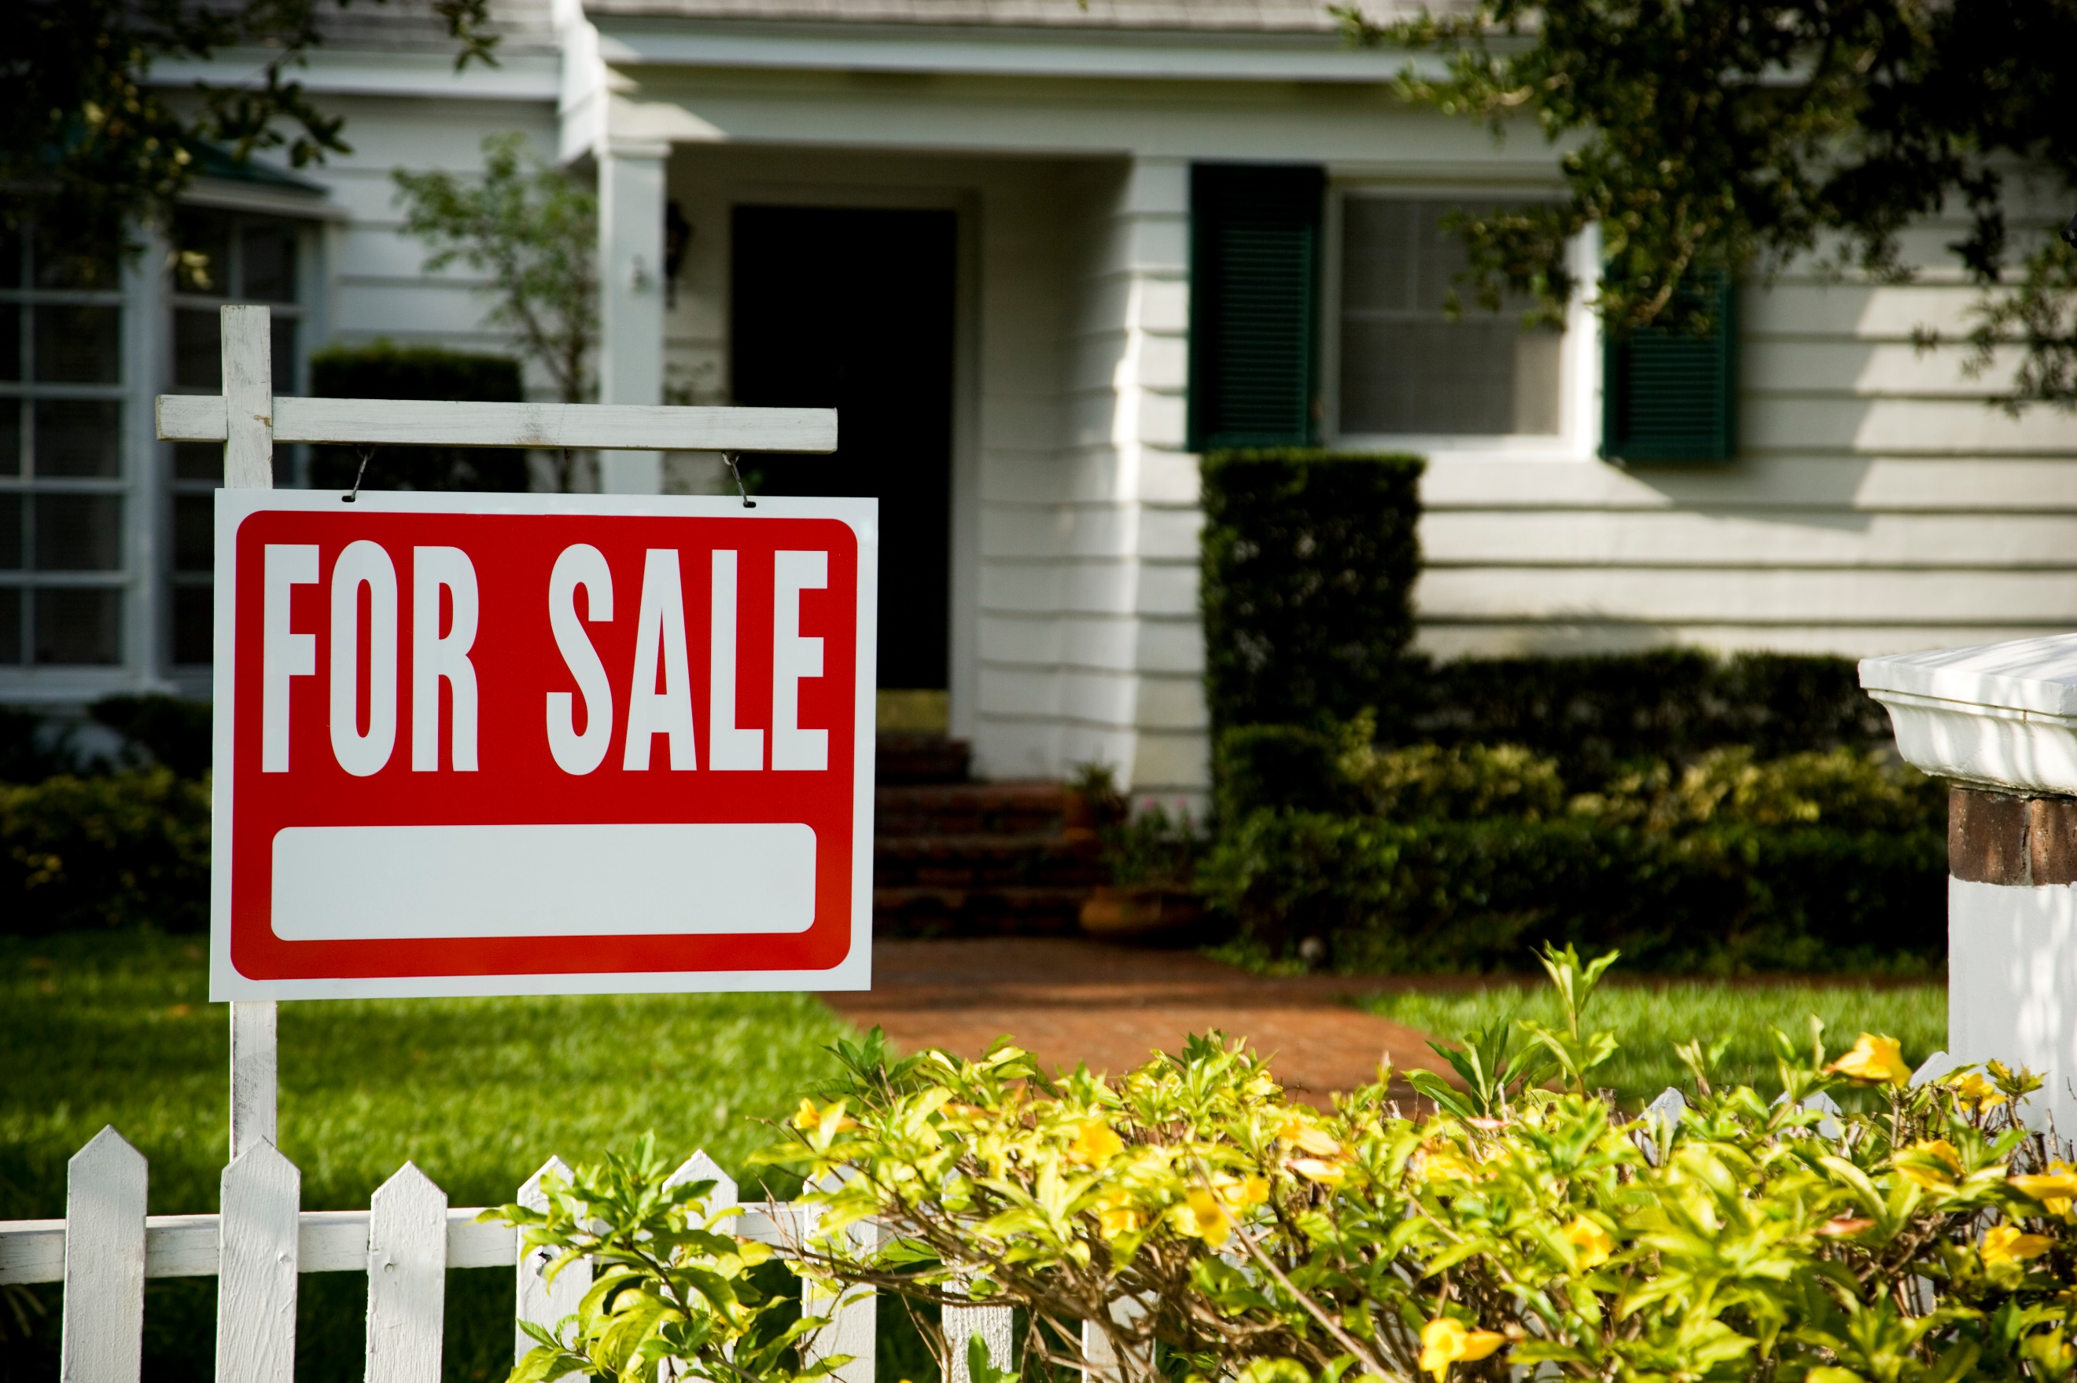

Here are the data from the surrounding houses.

|  |  |
| --- | --- |
| **Family** | **Yearly income ($)** |
| Family A | 1 000 000 |
| Family B | 225 000 |
| Family C | 80 000 |
| Family D | 60 000 |
| Family E | 40 000 |
| Family F | 30 000 |
| Family G | 20 000 |
| Family H | 20 000 |
| Family J | 15 000 |
| Family K | 10 000 |

**Find the mean, median, and mode of the yearly income.**

Mean: Median: Mode:

**What do you think happened?**