**CBC Indigenous Population 2021 Census**

**Data Management**

**Unit 1 Line Master 4**

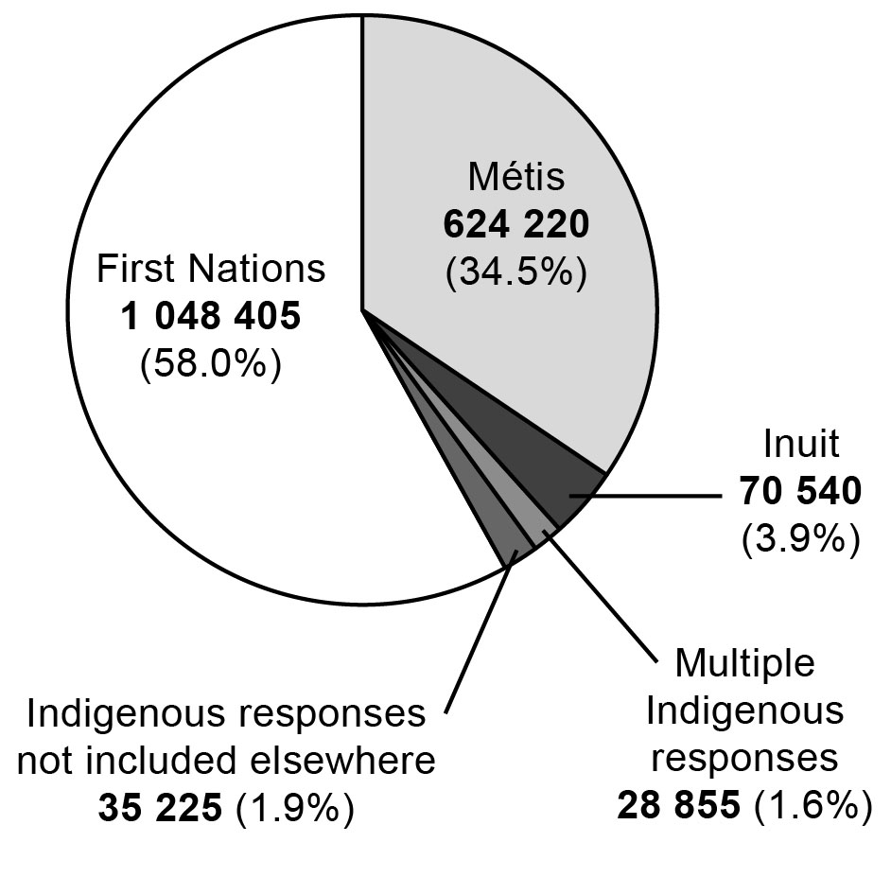

Source: Statistics Canada