What We Have in Common

**Algebra**

**Unit 6 Line Master 5a**

|  |  |
| --- | --- |
| 1. For each inequality, plot points that are a solution to that inequality. Colour the box next to the inequality to show which colour you used for those points. Find points that are solutions to all three inequalities. | ◻ 𝑥 + 𝑦 < 10  ◻ 𝑦 ≤ 3𝑥 + 1  ◻ 𝑥𝑦 > 5 |

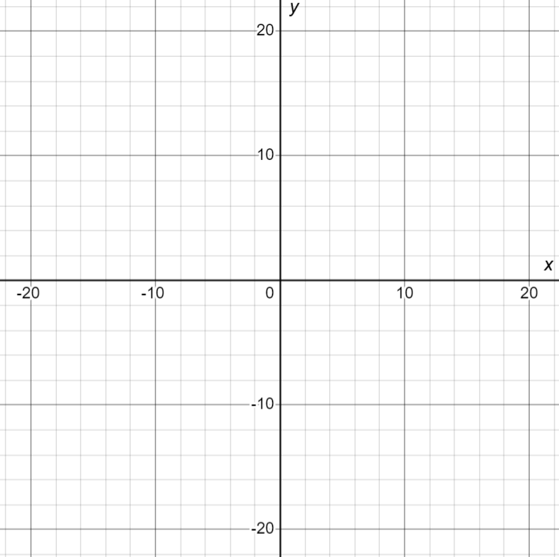

What We Have in Common (cont’d)

**Algebra**

**Unit 6 Line Master 5b**

|  |  |
| --- | --- |
| 2. Create two inequalities of your own such that the region  where points are solutions to both inequalities is small compared to the overall graph area. | ◻ _________________  ◻ _________________ |

