Are You the Solution? Answers

**Algebra**

**Unit 6 Line Master 4c**

1. $x-6≤2$

$x-6+6≤2+6$

$x≤8$

Choose a value less than 8: *x* = 4  
L.S. = $x-6$ R.S.= $2$

= $4-6$

= $-2$  
‒2 $≤$ 2, so the solution is correct.

2. $-2x>32$

$\frac{-2x}{-2}$ < $\frac{32}{-2}$

$x<-16$

Choose a value less than ‒16: *x* = ‒20  
L.S. = $-2x$ R.S.= $32$

= $-2(-20)$

= $40$  
40 >32, so the solution is correct.

3. $-\frac{p}{8}<2$



$8 ×\left(-\frac{p}{8}\right)<2 ×8$

$-p<16$

$p>-16$

Choose a value greater than ‒16: *p* = 0  
L.S. = $-\frac{p}{8}$ R.S.= $2$

= $-\frac{0}{8}$

= $0$  
0 < 2, so the solution is correct.

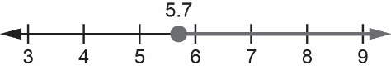4. $q-3.2≥2.5$

$q-3.2+3.2≥2.5+3.2$

$q≥5.7$

Choose a value greater than 5.7: *q* = 6  
L.S. = $q-3.2$ R.S.= $2.5$

= $6-3.2$

= $2.8$  
2.8 $≥$ 2.5, so the solution is correct.

Are You the Solution? Answers (cont’d)

**Algebra**

**Unit 6 Line Master 4d**

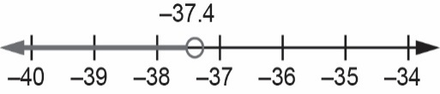

5. $2y+13.3<y –24.1$

$$2y+13.3 -13.3<y –24.1-13.3$$

$2y<y –37.4$

$2y-y<y-y –37.4$

$y<-37.4$

Choose a value less than ‒37.4: *y* = ‒40  
L.S. = $2y+13.3$ R.S.= $y –24.1$

= $2(-40)+13.3$ = $-40 –24.1$

= $-66.7$ = ‒64.1   
‒66.7 < ‒64.1, so the solution is correct.

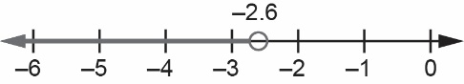6. $9.5 –2.5a>16$

$$9.5 –2.5a+2.5a>16+2.5a$$

$9.5>16+2.5a$

$9.5 -16>16-16+2.5a$

$-6.5>2.5a$

$\frac{-6.5}{2.5}>\frac{2.5a}{2.5}$

$-2.6>a$

Choose a value less than ‒2.6: *a* = ‒4  
L.S. = $9.5 –2.5a$ R.S.= $16$

= $9.5 –2.5(-4)$

= $19.5$  
19.5 > 16, so the solution is correct.

7. Let *p* represent the length of pipe used, in metres.

$35-p ≥7$

$35-p+p≥7+p$

$35≥7+p$

$35-7≥7-7+p$

$28≥p$ They could have used a length of 28 m or less (but greater than 0 m).

8. Let *t* represent the time, in minutes, spent on social media each weekday.



$5t+127<562$

$$5t+127-127 <562-127$$

$5t<435$

$\frac{5t}{5}<\frac{435}{5}$

$t<87$

They could spend any time less than 87 min on social media each weekday.