Number Lines

**Algebra**

**Unit 6 Line Master 2a**

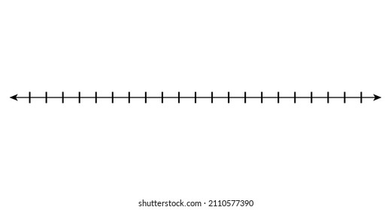













Number Lines

**Algebra**

**Unit 6 Line Master 2b**

