Buried in Bags (Accommodation)

**Algebra**

**Unit 4 Line Master 2**

Five companies tracked how many plastic bags (rounded to the nearest hundred thousand) they used over four years, starting in 2019.   
The companies recorded and submitted their data in different ways.

|  |  |
| --- | --- |
| **Company A** | |
| **Years since 2019** | **Bags used (in hundred thousands)** |
| 0 | 14.0 |
| 1 | 14.5 |
| 2 | 15.0 |
| 3 | 15.5 |

|  |  |
| --- | --- |
| **Company B** | |
| **Years since 2019** | **Bags used**  **(in hundred thousands)** |
| 0 | 28 |
| 1 | 26 |
| 2 | 24 |
| 3 | 22 |

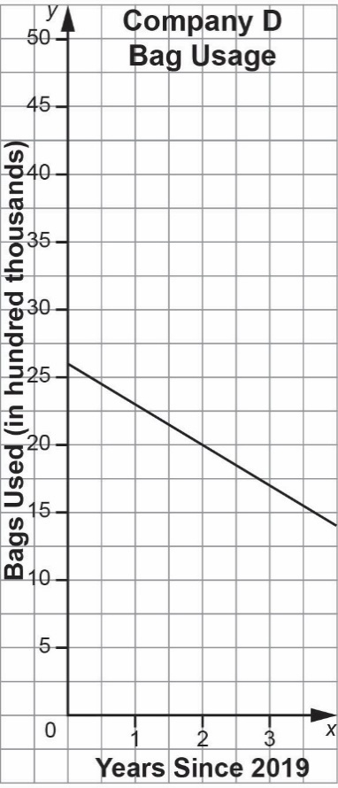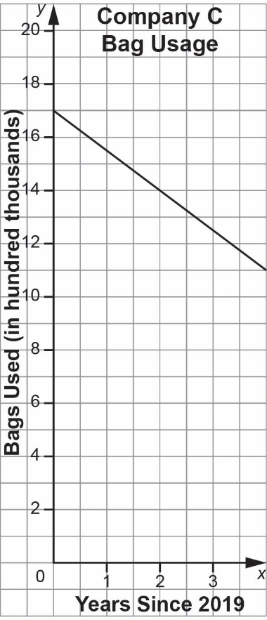

Company E: Reported using 1 800 000 bags in 2019 and used 250 000 fewer bags each year since.

**Algebra**

**Unit 4 Line Master 2**

Buried in Bags (Accommodation) (cont’d)

1. For each company, calculate the rate of change for bag usage.

2. For each company, identify the initial value for bag usage.

3. Which company had the greatest initial bag usage?

4. Which companies had decreasing rates of change for bag usage?

5. Which company is doing the best job at minimizing bag use?

Which company is doing the worst job? Justify your claims.