Buried in Bags

**Algebra**

**Unit 4 Line Master 1**

Five companies tracked how many plastic bags (rounded to the nearest hundred thousand) they used over four years, starting in 2019. The companies recorded and submitted their data in different ways.

Determine the rate of change and the initial value for each company.  
Use the information to determine which company is doing the best job at minimizing bag use.   
Which company is doing the worst job? Justify your claims.

|  |  |
| --- | --- |
| **Company A** | |
| **Years since 2019** | **Bags used (in hundred thousands)** |
| 0 | 14.0 |
| 1 | 14.5 |
| 2 | 15.0 |
| 3 | 15.5 |

|  |  |
| --- | --- |
| **Company B** | |
| **Years since 2019** | **Bags used**  **(in hundred thousands)** |
| 0 | 28 |
| 1 | 26 |
| 2 | 24 |
| 3 | 22 |

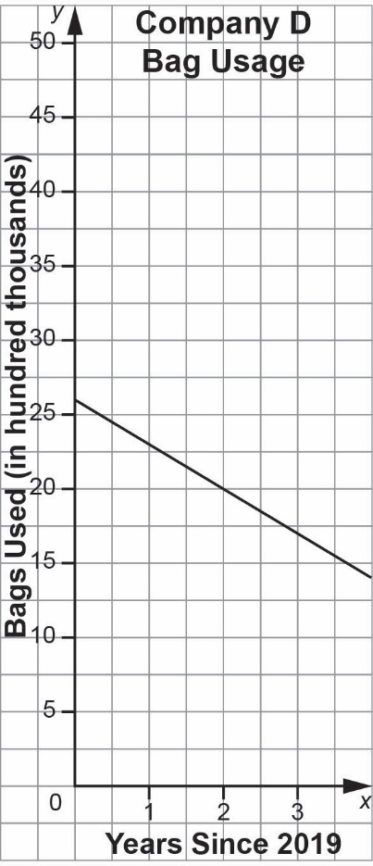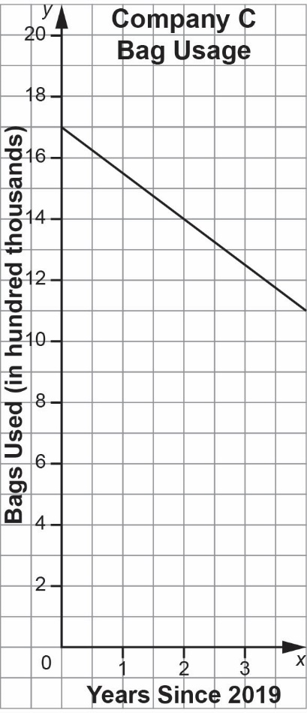

Company E: Reported using 1 800 000 bags in 2019 and used 250 000 fewer bags each year since.