**Visualizing Situations**

**Algebra**

**Unit 3 Line Master 5a**

1. Consider this situation:   
 A basketball player shoots a ball at the net.   
 Which graph could represent the ball’s distance from the player over time?   
 Explain your thinking.

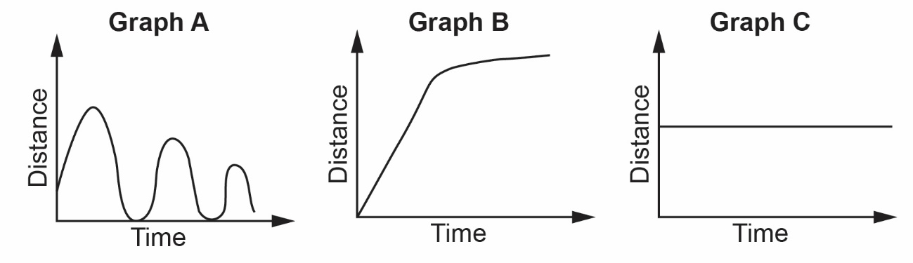

2. Consider another scenario:

A bus leaves the station and travels along its route before returning to the station.

Which graph could represent the bus’s distance from the station?

Explain your thinking.

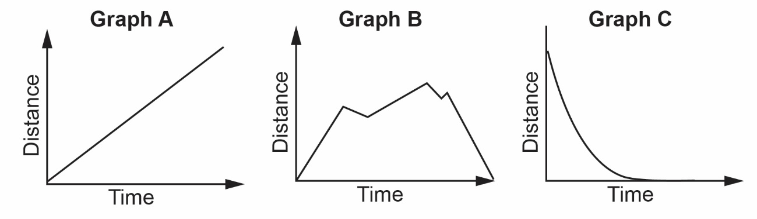

**Visualizing Situations** (cont’d)

**Algebra**

**Unit 3 Line Master 5b**

3. Choose one of these situations, then draw a graph to represent it.

* The value of a car over time
* The height of a basketball after each bounce
* The height of a golf ball from the time it is driven to the time it lands
* The average daily temperature over a year for your city
* The cost of participating in yoga classes
* The number of hours worked versus money earned

Is the relation linear or non-linear? Explain.