Who is Faster?   
Who is Farther Away?

**Algebra**

**Unit 2 Line Master 8**

In each situation below, a pair of birds fly to the same destination, but they start from different locations. For each bird, *k* is the distance remaining, in kilometres,   
and *h* is the number of hours travelled.

For each pair of birds, identify:

* Which bird flies faster?
* Which bird started farther away?
* Which bird will reach its destination first?

Pair 1

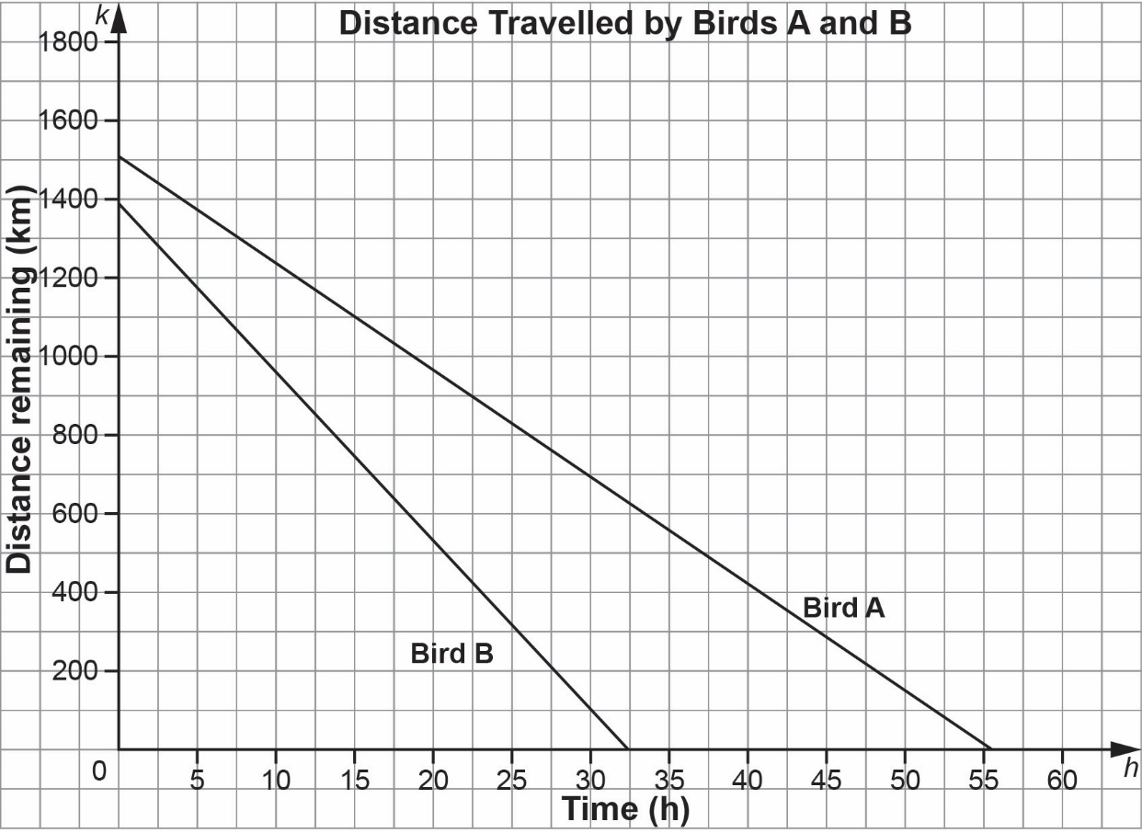

Pair 2

Bird C: $k=-32h+1520$ Bird D: $k=-38h+2120$

**Who is Faster?   
Who is Farther Away?** (cont’d)

**Algebra**

**Unit 2 Line Master 8**

Pair 3

|  |  |  |  |  |
| --- | --- | --- | --- | --- |
| **Bird E** | |  | **Bird F** | |
| **Number of hours, *h*** | **Distance remaining, *k* (km)** |  | **Number of hours, *h*** | **Distance remaining, *k* (km)** |
| 0 | 2342 |  | 0 | 2137 |
| 5 | 2302 |  | 5 | 2106 |
| 10 | 2262 |  | 10 | 2075 |
| 15 | 2222 |  | 15 | 2044 |
| 20 | 2182 |  | 20 | 2013 |