
How many xihwu (urchins)?
Algebra
Unit 2 Line Master 3

Roll three number cubes.
- Put one number cube in each box to show how many the raven ate, how many are carried each trip, and how many trips there were.
- Use the values to complete the table.
- Write an equation to represent the relation.
- The player with the greater number of xihwu after the given number of trips gets one point.

Number of trips:
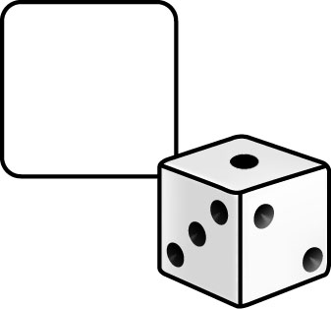
Raven ate:

Xihwu (urchins) per trip:
Equation:
Number of trips | Number of xihwu (urchins)
0
1
2
3
4
5
6

Adapted from Numeracy Explorations through Coast Salish Story by Tannis Reis Calder (sd68)

