Polynomial Equivalency
Algebra
Unit 1 Line Master 9a

Test your ability to find equivalent polynomials!
- Use the set of hexagon cards provided. Some blank cards are provided if you wish to extend the game by adding your own polynomials.
- Cut out the cards and lay them face up.
- Connect the hexagons to form a “honeycomb” shape so that touching sides represent equivalent polynomials.
- Challenge yourself or other teams to see how quickly you can identify
equivalent polynomials.
Hint: Blank sides form the border of your honeycomb!

Why do honeybees use a hexagonal shape in their honeycombs?
do


Polynomial Equivalency (cont’d)
Algebra
Unit 1 Line Master 9b

Hexagon Cards (Sheet 1)

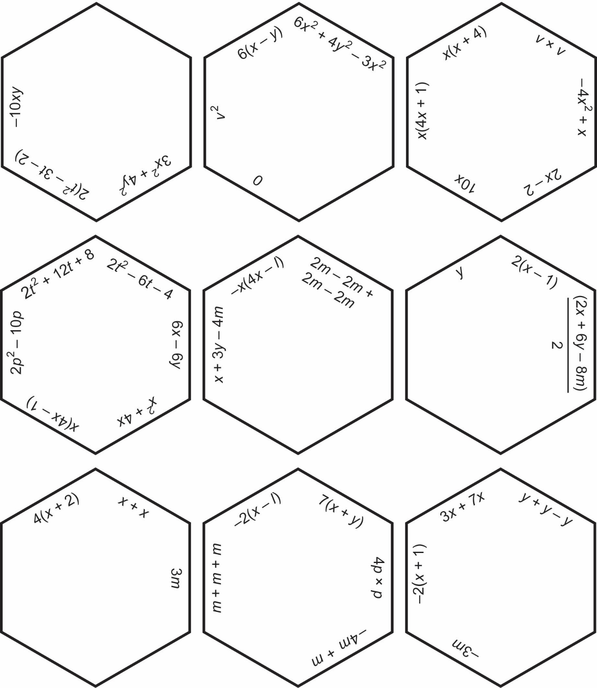

Polynomial Equivalency (cont’d)
Algebra
Unit 1 Line Master 9c

Hexagon Cards (Sheet 2)

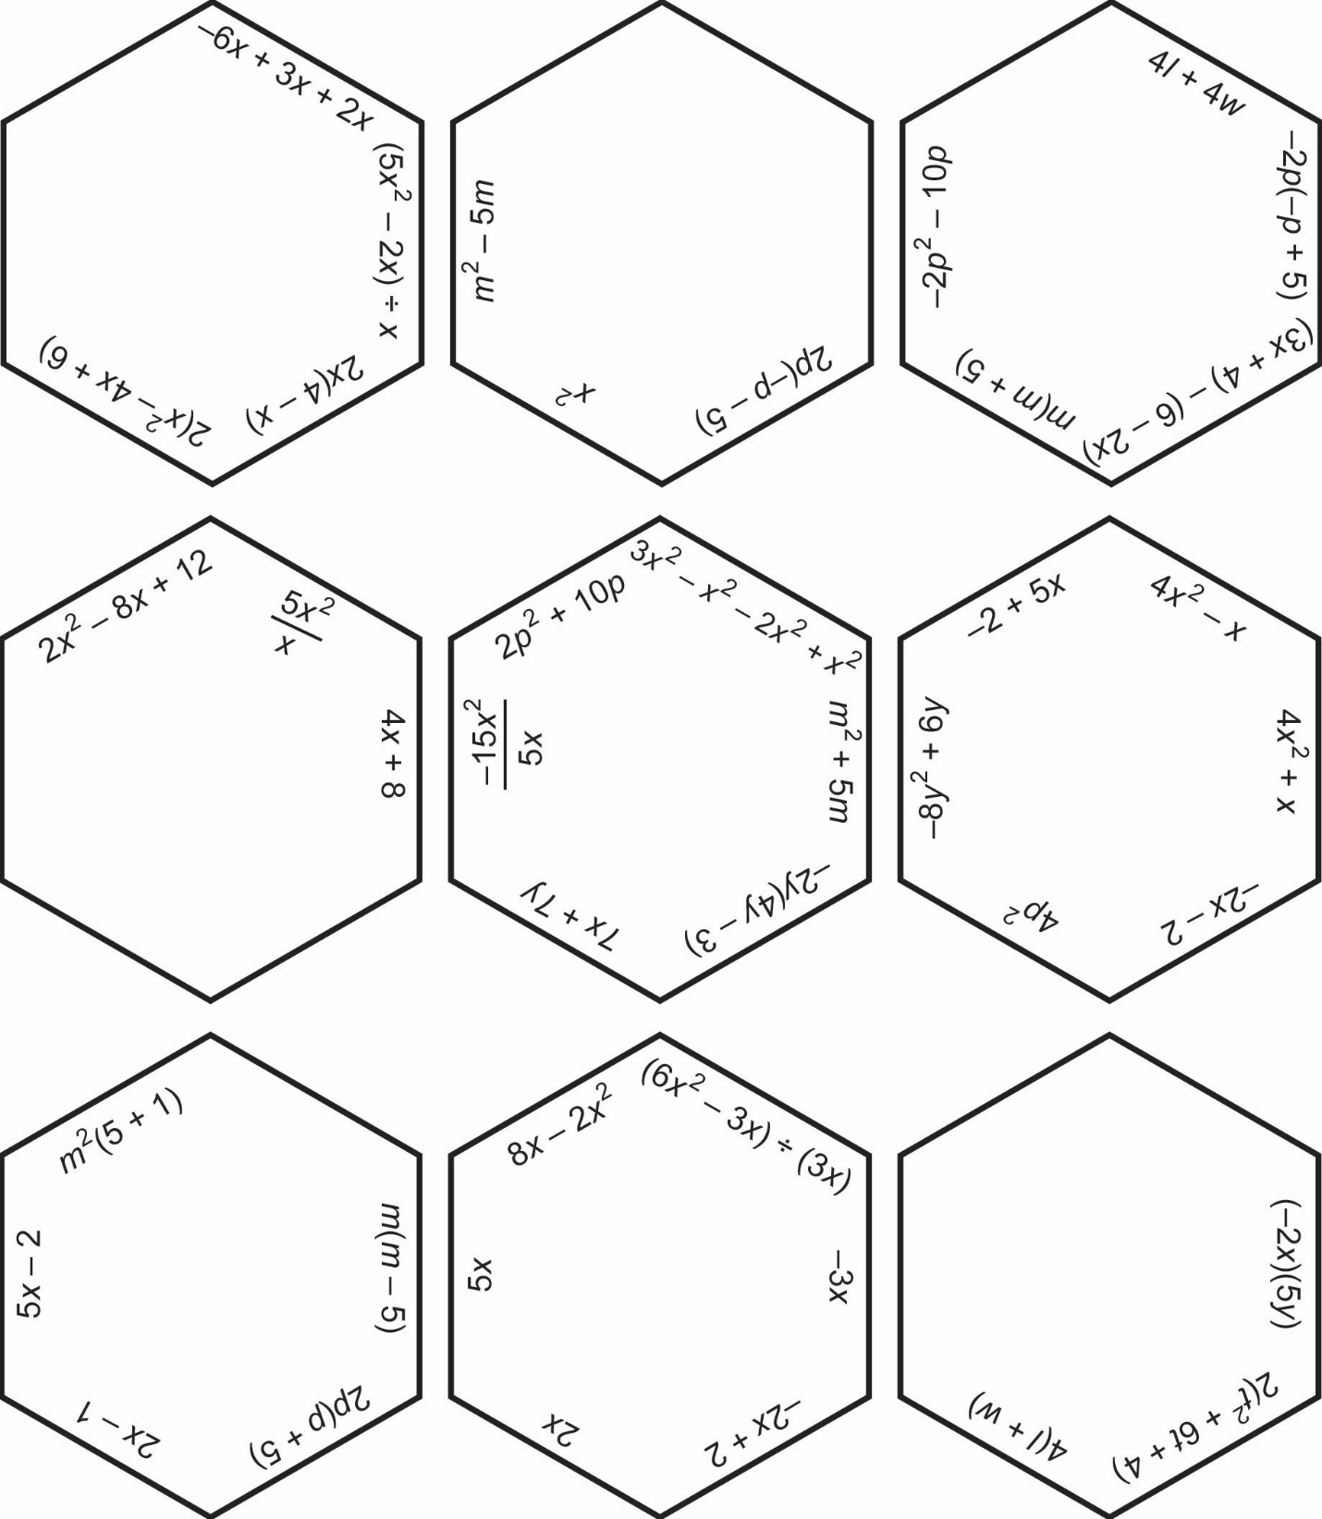

Polynomial Equivalency (cont’d)
Algebra
Unit 1 Line Master 9d

Blank Hexagon Cards
