***Multiplying and Dividing Polynomials*   
 Answers**

**Algebra**

**Unit 1 Line Master 8e**

**Part A: Multiplying Polynomials**

1. 2*x* represents the product of 2 × (*x*).

Model (*x*)× (*x*)*.*  Model 2 × (*x*)*.*

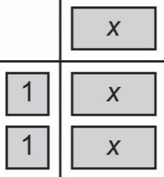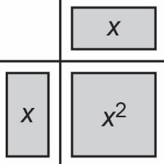

The two models are not equivalent*.*So,(*x*)× (*x*) *≠* 2*x.*

2. a) 2*x*(3*x* + 1) = 6*x*2 + 2*x*

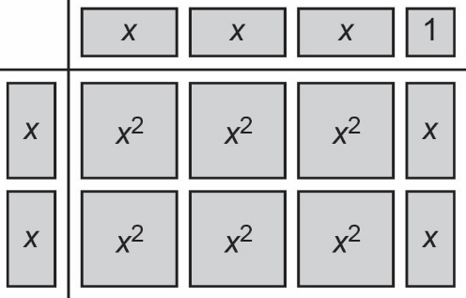

b) −3*x*(4*x* − 1) = −12*x*2 + 3*x*

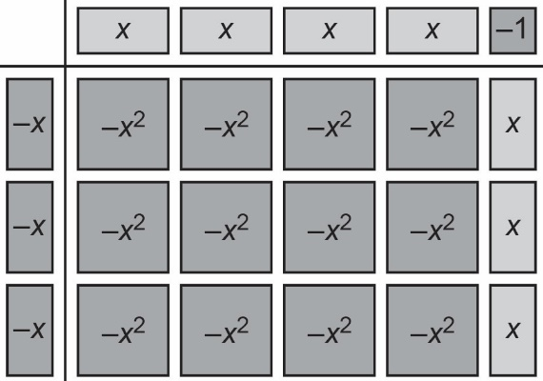

***Multiplying and Dividing Polynomials*   
 Answers** (cont’d)

**Algebra**

**Unit 1 Line Master 8f**

3. a) 2(2*x*² − 3*x* + 1) = 4*x*² − 6*x* + 2

b) 4(5*y*² − 3*y* + 8) = 20*y*² − 12*y* + 32

c) −6*x*(−2*x* − 9) = 12*x*² + 54*x*

**Part B: Dividing Polynomials**

1. I know that when I divide a polynomial by a monomial, I can write each term of the polynomial as a division with the monomial as the denominator. For example,

(−6*x2* + 12*x*) ÷3*x* can be written as $\frac{-6x^{2}}{3x}+ \frac{12x}{3x}$.

I can then simplify the individual fractions.

I also know that when dividing like terms with different exponents, I subtract the exponents. So, *x*2 ÷ *x* = *x*, because 2 − 1 = 1.

2. a) (8*x*² + 2*x*) ÷ (2*x*) = $\frac{8x^{2}}{2x}+ \frac{2x}{2x}$

= 4*x* + 1

b) (−6*x*² − 3*x*) ÷ (−3*x*) = $\frac{-6x^{2}}{-3x}+ \frac{-3x}{-3x}$

= 2*x* + 1

c) (−6*x*² − 8*x*) ÷ (2*x*) = $\frac{-6x^{2}}{2x}+ \frac{-8x}{2x}$

= ‒3*x* ‒ 4

***Multiplying and Dividing Polynomials*   
 Answers** (cont’d)

**Algebra**

**Unit 1 Line Master 8g**

3. a) = (‒3*s*)(‒4*s*)

= 12*s*2

b) The order of operations tells me that I need to simplify the expression inside the first set of brackets before multiplying by the expression in the second set of brackets. If I didn’t do this, I would have to multiply and divide larger numbers: $\frac{-36s^{2}}{-3}$. The answer would be the same because the order in which multiplication and division are performed doesn’t matter.

4. a) (14*x*² − 7*x*) ÷ 7*x* =

= 2*x* ‒ 1

b) (‒8*x*² + 6*x* ‒ 4) ÷ 2 =

= ‒4*x*2 + 3*x* ‒ 2

c) = (‒2*m*)(‒3*m*)

= 6*m*2