**Subtracting Polynomials**

**Algebra**

**Unit 1 Line Master 5a**

Use algebra tiles to help answer the questions below.

1. a) Model 3*x.*

b) Show how you could remove 2*x*. Write the process symbolically.

c) Model and simplify 3*x* + (−2*x*).

d) How are addition and subtraction related?

1. Rewrite each polynomial using only addition.
2. *x*² − 6*x* + 3
3. −4*x*² − 9

3. Simplify each polynomial.

1. 3*x*² − 5*x* + 2*x* − *x*² − 7
2. −4x² + 7*x* − x² − 3 + (−4*x*)

**Subtracting Polynomials** (cont’d)

**Algebra**

**Unit 1 Line Master 5b**

4. Colin modelled and simplified 5*x* − (−*x*) as shown below.

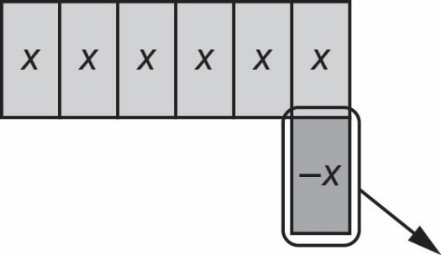

a) Why did Colin add a zero pair to the model?

b) What is the result of this subtraction?

c) How does this result relate to the statement “subtracting is the same as   
adding the opposite”?

5. Sara completed the subtraction (2*x* + 8) − (3*x* − 6) by first rewriting it   
as (2*x* + 8) + (−3*x* + 6).

a) Why did Sara change the terms in the second bracket to −3*x* + 6?

b) Sara got the answer −1*x* + 14. Is their answer correct?

c) Use Sara’s method to complete this subtraction.

(−4*m*² − 5*m* − 6) − (−7*m*² + 3*m* − 1)