***Subtracting Polynomials* Answers**

**Algebra**

**Unit 1 Line Master 5c**



1. a)

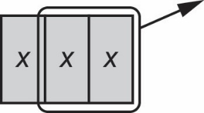

b)

3*x* − 2*x* = *x*

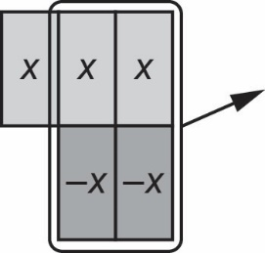c)

3*x* + (−2*x*) = *x*

d) Subtracting a polynomial gives the same answer as adding the opposite polynomial.

3*x* − 2*x =* 3*x* + (−2*x*)

2. a) *x*² + (−6*x*) + 3

b) −4*x*² + (−9)

3. a) 2*x*² − 3*x* − 7

b) −5x² + 3*x* − 3

4. a) There was no −*x*-tile to remove. By adding a zero pair, the −*x*-tile can now be removed, leaving 6 *x*-tiles.

b) 6*x*

c) 5*x* − (−*x*) = 5*x* + (+*x*)

= 6*x*

5. a) Sara wanted to add the opposite. The opposite of 3*x* is −3*x* and the opposite   
of −6 is +6.

b) Yes, Sara’s answer is correct.

c) (−4*m*² − 5*m* − 6) − (−7*m*² + 3*m* − 1) = (−4*m*² − 5*m* − 6) + (7*m*² − 3*m* + 1)

= 3*m*² − 8*m* − 5