**Exploring Algebraic Expressions   
 with Coding**

**Algebra**

**Unit 1 Line Master 3a**

There are many ways to represent algebraic expressions, including through words, tables of values, tiles, and graphs.

For example, the tiles below represent the first three terms of the expression 2*n* + 3.

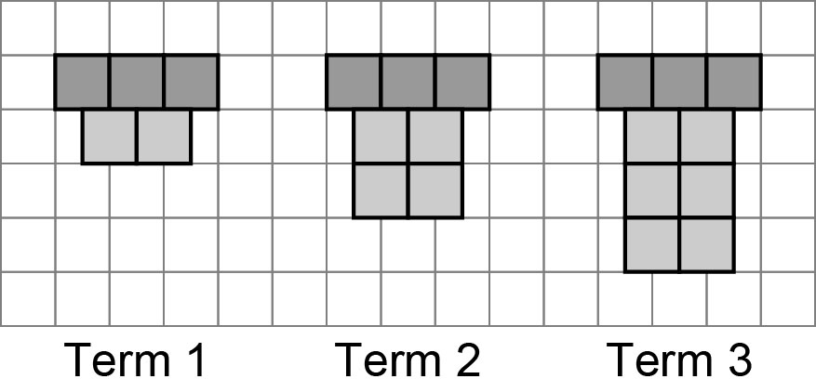

You can also represent algebraic expressions through coding.

1. Let’s generate a table of values for any number of terms.

1. Copy this exact code into a Python console, such as [Google Colab](https://colab.research.google.com/) or <https://cscircles.cemc.uwaterloo.ca/console/>.

for i in range (1,10):

termNumber = i

termValue = 2 * termNumber

print (termNumber, '\t', termValue)

**About the Code:** “for” indicates the start of a repeat. Everything that is indented below *for*, is included in the repeat. The first time through the repeat,   
*i* is 1, then 2, then 3, up to but not including 10.   
The **termNumber** variableis set to the value of *i*.

**Exploring Algebraic Expressions   
 with Coding** (cont’d)

**Algebra**

**Unit 1 Line Master 3b**

|  |  |
| --- | --- |
| **1** | **2** |
| **2** | **4** |
| **3** | **6** |
| **4** | **8** |
| **5** | **10** |
| **6** | **12** |
| **7** | **14** |
| **8** | **16** |
| **9** | **18** |

When you execute the code by running it,   
your output should look like this:

b) What is the numerical coefficient, or multiplier?

c) What algebraic expression does the output represent?

1. The code has been altered so that it will output the numbers 1 through 100, **including** 100:

for i in range (1,101):

termNumber = i

termValue = 2 * termNumber

print (termNumber, '\t', termValue)

Describe the output generated with the altered code.

**About the Code:**

* means to multiply in coding.

* Each time through the loop, the values of the **termNumber**   
  and **termValue** variables are updated and output.
* So, the first time through the loop, **termNumber** is 1   
  and **termValue** is 2* 1, which is 2.
* The second time through the loop, **termNumber** is 2   
  and **termValue** is 2* 2, which is 4.
* The third time through the loop, **termNumber** is 3   
  and **termValue** is 2* 3, which is 6.

And so on!

**Exploring Algebraic Expressions   
 with Coding** (cont’d)

**Algebra**

**Unit 1 Line Master 3c**

1. The code has been altered so that it will output a table of values for the expression 3*n* for **termNumber** 1 through 50.

for i in range (1,51):

termNumber = i

termValue = 3 * termNumber

print (termNumber, '\t', termValue)

1. Describe the new output generated.
2. What is the numerical coefficient, or multiplier for this expression?

c) What algebraic expression does the output represent?

|  |  |
| --- | --- |
| **1** | **10** |
| **2** | **20** |
| **3** | **30** |
| **4** | **40** |
| **5** | **50** |

4. Alter the code so that each of these outputs are generated:

|  |  |
| --- | --- |
| **1** | **4** |
| **2** | **8** |
| **3** | **12** |
| **4** | **16** |
| **5** | **20** |
| **6** | **24** |
| **7** | **28** |
| **8** | **32** |
| **9** | **36** |
| **10** | **40** |

|  |  |
| --- | --- |
| **1** | **6** |
| **2** | **12** |
| **3** | **18** |
| **4** | **24** |
| **5** | **30** |
| **6** | **36** |
| **7** | **42** |
| **8** | **48** |
| **9** | **54** |
| **10** | **60** |

a) b) c)

**Exploring Algebraic Expressions   
 with Coding** (cont’d)

**Algebra**

**Unit 1 Line Master 3d**

5. The code has been altered to display a table of values for the expression 2n + 1, showing the output for **termNumber** 0 through 15.

for i in range (1,16):

termNumber = i

termValue = 2 * termNumber + 1

print (termNumber, '\t', termValue)

**About the Code:** In this case, **termNumber** is starting at 0.

Your output should look like this:

|  |  |
| --- | --- |
| **0** | **1** |
| **1** | **3** |
| **2** | **5** |
| **3** | **7** |
| **4** | **9** |
| **5** | **11** |
| **6** | **13** |
| **7** | **15** |
| **8** | **17** |
| **9** | **19** |
| **10** | **21** |
| **11** | **23** |
| **12** | **25** |
| **13** | **27** |
| **14** | **29** |
| **15** | **31** |

a) What is the numerical coefficient, or multiplier?

b) What is the constant?

**Exploring Algebraic Expressions   
 with Coding** (cont’d)

**Algebra**

**Unit 1 Line Master 3e**

**Reflect and Connect**

6. a) How would you alter the code to represent the expression 4*n* + 3,   
showing the output for **termNumber** 0 through 100.

b) Describe the output.

7. Alter the code to generate output using different expressions.   
Challenge your classmates by covering your code and having them   
try to determine what expression you used to produce   
the output generated.