***Exploring Algebraic Expressions   
 with Coding* Answers**

**Algebra**

**Unit 1 Line Master 3f**

There are many ways to represent algebraic expressions, including through words, tables of values, tiles, and graphs.

For example, the tiles below represent the first three terms of the expression 2*n* + 3.

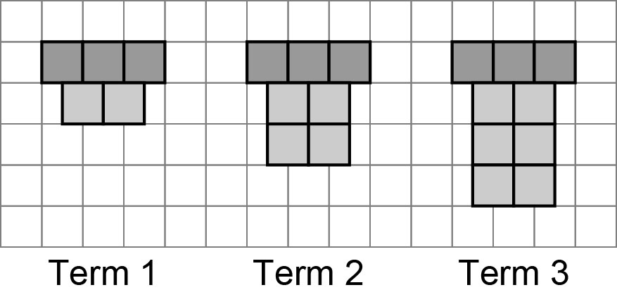

You can also represent algebraic expressions through coding.

1. Let’s generate a table of values for any number of terms.

1. Copy this exact code into a Python console, such as [Google Colab](https://colab.research.google.com/) or <https://cscircles.cemc.uwaterloo.ca/console/>.

for i in range (1,10):

termNumber = i

termValue = 2 * termNumber

print (termNumber, '\t', termValue)

**About the Code:** “for” indicates the start of a repeat. Everything that is indented below *for*, is included in the repeat. The first time through the repeat,   
*i* is 1, then 2, then 3, up to but not including 10.   
The **termNumber** variableis set to the value of *i*.

***Exploring Algebraic Expressions   
 with Coding* Answers** (cont’d)

**Algebra**

**Unit 1 Line Master 3g**

|  |  |
| --- | --- |
| **1** | **2** |
| **2** | **4** |
| **3** | **6** |
| **4** | **8** |
| **5** | **10** |
| **6** | **12** |
| **7** | **14** |
| **8** | **16** |
| **9** | **18** |

When you execute the code by running it,

your output should look like this:

b) What is the numerical coefficient, or multiplier?  
**The multiplier is 2.**

c) What algebraic expression does the output represent?

**The algebraic expression is 2*n*.**

1. Alter the code so that it will output the numbers 1 through 100, **including** 100:

for i in range (1,101):

termNumber = i

termValue = 2 * termNumber

print (termNumber, '\t', termValue)

Describe the output generated with the altered code.

**The output displays termNumber 1 through 100 and the corresponding termValue, starting at 2 and ending at 200 for the 100th term number. The expression doubles the termNumber each time to obtain the termValue.**

**About the Code:**

* means to multiply in coding.

* Each time through the loop, the values of the **termNumber**   
  and **termValue** variables are updated and output.
* So, the first time through the loop, **termNumber** is 1   
  and **termValue** is 2* 1, which is 2.
* The second time through the loop, **termNumber** is 2   
  and **termValue** is 2* 2, which is 4.
* The third time through the loop, **termNumber** is 3   
  and **termValue** is 2* 3, which is 6.

And so on!

***Exploring Algebraic Expressions   
 with Coding* Answers** (cont’d)

**Algebra**

**Unit 1 Line Master 3h**

1. Alter the code so that it will output a table of values with the first 50 terms   
   of the expression 3*n*.

for i in range (1,51):

termNumber = i

termValue = 3 * termNumber

print (termNumber, '\t', termValue)

a) Describe the new output generated.

**The output displays termNumber 1 through 50 along with each termValue which will be the termNumber multiplied by 3. The first termValue is 3, and the last is 150.**

b) What is the numerical coefficient, or multiplier for this expression?

**The numerical coefficient is 3.**

c) What algebraic expression does the output represent?

**The algebraic expression is 3*n*.**

4. Alter the code so that each of these outputs are generated:

|  |  |
| --- | --- |
| **1** | **4** |
| **2** | **8** |
| **3** | **12** |
| **4** | **16** |
| **5** | **20** |
| **6** | **24** |
| **7** | **28** |
| **8** | **32** |
| **9** | **36** |
| **10** | **40** |

|  |  |
| --- | --- |
| **1** | **6** |
| **2** | **12** |
| **3** | **18** |
| **4** | **24** |
| **5** | **30** |
| **6** | **36** |
| **7** | **42** |
| **8** | **48** |
| **9** | **54** |
| **10** | **60** |

a) b) c)

|  |  |
| --- | --- |
| **1** | **10** |
| **2** | **20** |
| **3** | **30** |
| **4** | **40** |
| **5** | **50** |

***Exploring Algebraic Expressions   
 with Coding* Answers** (cont’d)

**Algebra**

**Unit 1 Line Master 3i**

**Sample Answers**

|  |
| --- |
| **a)**  for i in range (1,11):  termNumber = i  termValue = 4 * termNumber  print (termNumber, '\t', termValue) |
| **b)**  for i in range (1,11):  termNumber = i  termValue = 6 * termNumber  print (termNumber, '\t', termValue) |
| **c)**  for i in range (1,6):  termNumber = i  termValue = 10 * termNumber  print (termNumber, '\t', termValue) |

5. Alter the code as shown below to display a table of values for the expression *2n* + 1, showing the output for **termNumbers** 0 to 15.

for i in range (1,16):

termNumber = i

termValue = 2 * termNumber + 1

print (termNumber, '\t', termValue)

**About the Code:** In this case, **termNumber** is starting at 0.

***Exploring Algebraic Expressions   
 with Coding* Answers** (cont’d)

**Algebra**

**Unit 1 Line Master 3j**

Your output should look like this:

|  |  |
| --- | --- |
| **0** | **1** |
| **1** | **3** |
| **2** | **5** |
| **3** | **7** |
| **4** | **9** |
| **5** | **11** |
| **6** | **13** |
| **7** | **15** |
| **8** | **17** |
| **9** | **19** |
| **10** | **21** |
| **11** | **23** |
| **12** | **25** |
| **13** | **27** |
| **14** | **29** |
| **15** | **31** |

a) What is the numerical coefficient, or multiplier?

**The numerical coefficient is 2.**

b) What is the constant?

**The constant is 1.**

**Reflect and Connect**

6. a) How would you alter the code to represent the expression 4*n* + 3,   
showing the output for **termNumbers** 0 through 100.

**Sample Answer**

for i in range (1,101):

termNumber = i

termValue = 4 * termNumber + 3

print (termNumber, '\t', termValue)

***Exploring Algebraic Expressions   
 with Coding* Answers** (cont’d)

**Algebra**

**Unit 1 Line Master 3k**

b) Describe the output.

**The termNumber 0 through to 100 are displayed along with the corresponding termValue, starting at 3 and ending at 403.**

7. Alter the code to generate output using different expressions.   
Challenge your classmates by covering your code and having them   
try to determine what expression you used to produce   
the output generated.

**Answers will vary.**