***Investigating Equivalency* Answers**

**Algebra**

**Unit 1 Line Master 2d**

1. a)

|  |  |  |  |  |
| --- | --- | --- | --- | --- |
| ***x*** | **2*x* − 3** |  | ***x*** | **−3 + 2*x*** |
| −1 | **2(−1) − 3 = −5** |  | −1 | **−3 + 2(−1) = −5** |
| 0 | **2(0) − 3 = −3** |  | 0 | **−3 + 2(0) = −3** |
| 1 | **2(1) − 3 = −1** |  | 1 | **−3 + 2(1) = −1** |
| 2 | **2(2) − 3 = 1** |  | 2 | **−3 + 2(2) = 1** |
| 3 | **2(3) − 3 = 3** |  | 3 | **−3 + 2(3) = 3** |

The polynomials are equivalent as they have the same values.

b)

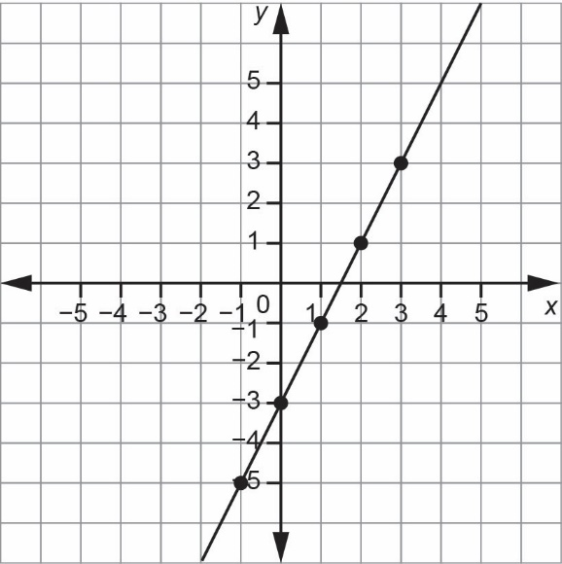

Both graphs are the same,   
so the expressions are equivalent.

c) Yes, they both use the same tiles, so they are equivalent.

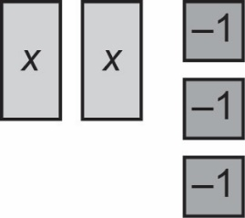 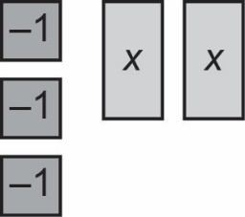

***Investigating Equivalency* Answers** (cont’d)

**Algebra**

**Unit 1 Line Master 2e**

1. a)

|  |  |  |  |  |
| --- | --- | --- | --- | --- |
| ***x*** | ***x*2 − 2*x* + 3** |  | ***x*** | **− 2*x* + *x*2 + 3** |
| −1 | **(**−1)**2 − 2(**−1) **+ 3 = 6** |  | −1 | **− 2(**−1) **+ (**−1)**2 + 3 = 6** |
| 0 | **(0**)**2 − 2(0**) **+ 3 = 3** |  | 0 | **− 2(0**) **+ (0**)**2 + 3 = 3** |
| 1 | **(**1)**2 − 2(**1) **+ 3 = 2** |  | 1 | **− 2(1**) **+ (1**)**2 + 3 = 2** |
| 2 | **(2**)**2 − 2(2**) **+ 3 = 3** |  | 2 | **− 2(2**) **+ (2**)**2 + 3 = 3** |
| 3 | **(3**)**2 − 2(3**) **+ 3 = 6** |  | 3 | **− 2(3**) **+ (3**)**2 + 3 = 6** |

The polynomials are equivalent as they have the same values.

b)

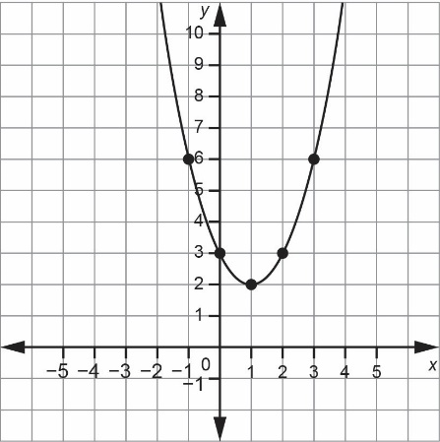

Both graphs are the same,   
so the expressions are equivalent.

c) Yes, they both use the same tiles.

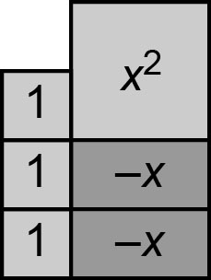 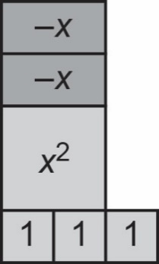

***Investigating Equivalency* Answers** (cont’d)

**Algebra**

**Unit 1 Line Master 2f**

1. a)

|  |  |  |  |  |
| --- | --- | --- | --- | --- |
| ***x*** | ***x*2** |  | ***x*** | **2*x*** |
| −2 | **4** |  | −2 | **−4** |
| −1 | **1** |  | −1 | **−2** |
| 0 | **0** |  | 0 | **0** |
| 1 | **1** |  | 1 | **2** |
| 2 | **4** |  | 2 | **4** |

The polynomials are not equivalent as they do not have the same values.

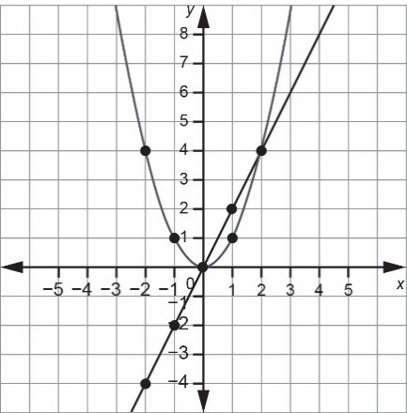b)

The graphs are different,   
so the expressions are not equivalent.

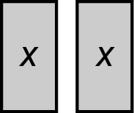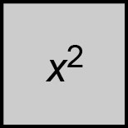c)

2*x*

*x*2

d) Alike: The graphs of both polynomials pass through the points (0, 0) and (2, 4).

Different: The tiles used to model the polynomials are different sizes and shapes.

The graph of *x*2 is a curve. The graph of 2*x* is a line.

These are not equivalent polynomials.