Determining Unknown Values in Proportional Situations
Understands and describes a proportional situation  “In a proportional situation, the two variables change at the same rate. They have the same ratio.  For example, if 1 pineapple costs $5, then 2 pineapples cost $10.” | Uses a ratio table to determine an unknown value  In a lake, the ratio of yellow perch  to northern pike caught is approximately 8:3.  150 northern pike were caught.  About how many yellow perch  were caught?  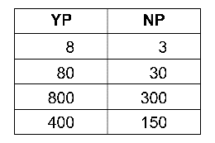  “About 400 yellow perch were caught.” | Uses a scale factor to determine an unknown value  In a lake, the ratio of yellow perch  to northern pike caught is approximately 8:3.  150 northern pike were caught.  About how many yellow perch  were caught?  “The scale factor is:  $\frac{YP}{NP}$= $\frac{8}{3}$  So, the number of yellow perch caught is:  $\frac{8}{3}$ × 150 = 400  About 400 yellow perch were caught.” | Uses a proportion to determine an unknown value  In a lake, the ratio of yellow perch  to northern pike caught is approximately 8:3.  150 northern pike were caught.  About how many yellow perch  were caught?  “Let y represent the number of yellow perch caught.  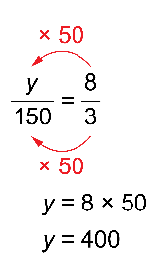  About 400 yellow perch were caught.”
Observations/Documentation

