Comparing Constant Rates and Initial Values
Understands how linear graphs can represent real-life situations  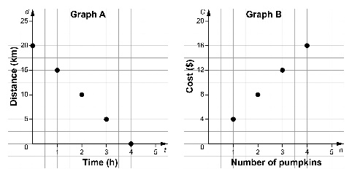  Graph A represents the distance remaining on a 20-km hike, when walking at an average speed of  5 km/h.  Graph B represents the cost of different numbers of pumpkins,  when 1 pumpkin costs $4.00. | Compares graphs with the same initial value  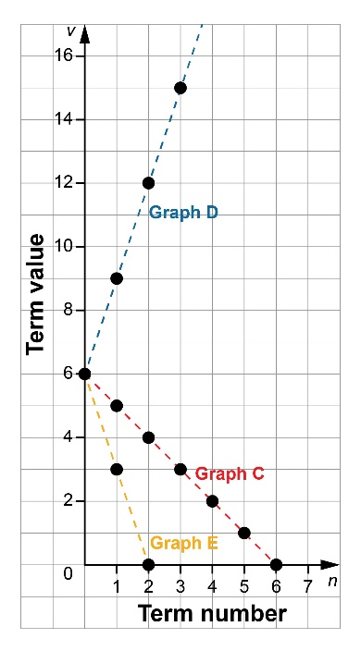  All graphs have the same initial value of 6, because they intersect the vertical axis at that point.  Graph C decreases at a constant rate of –1.  Graph D increases at a constant rate of 3.  Graph E decreases at a constant rate of –3. | Compares graphs with the same constant rate  All graphs have the same constant rate of –2 because they are parallel and go down to the right.  Graph F has an initial value of 12.  Graph G has an initial value of 9.  Graph H has an initial value of 5. | Solves problems involving constant rates and initial values  Kim is planning a fundraiser.  Venue A costs $100, plus $15  per person.  Venue B costs $200, plus $10  per person.  Which venue is the better deal? Why?  Make tables of values.  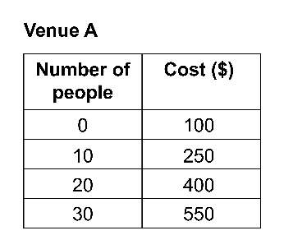  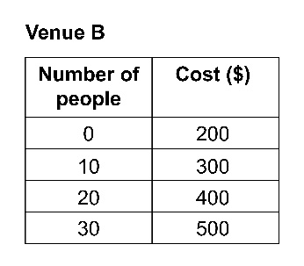  If fewer than 20 people attend (unlikely), then Venue A is cheaper.  If more than 20 people attend, Venue B is cheaper.
Observations/Documentation

