Exploring Constant Rates and Initial Values in Patterns
Understands the different ways a linear pattern can be represented  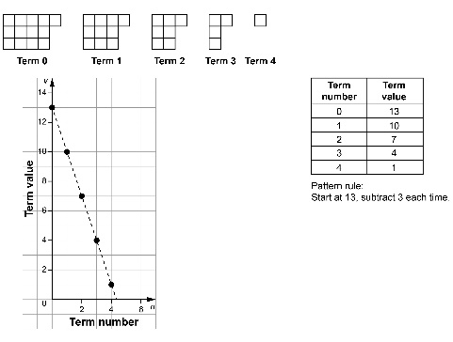 | Recognizes the differences between graphs of a growing pattern and a shrinking pattern  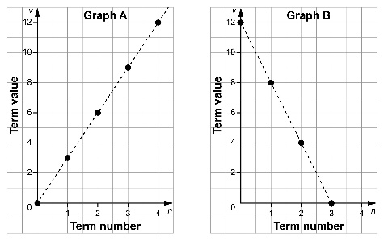  Graph A is a growing pattern because it goes up to the right.  Graph B is a shrinking pattern because it goes down to the right. | Identifies the initial value and the constant rates for linear patterns  Refer to the graphs in column 2.  Graph A:  initial value is 0, constant rate is 3  Graph B:  initial value is 12, constant rate is –4 | Explains how changes in initial value and constant rate change the graph of a linear pattern  Refer to the graphs in column 2.  Graph A: When I change the initial value to 2 and keep the constant rate at 3, the two graphs are parallel.  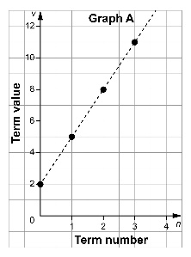  Graph B: When I keep the initial value and change the constant rate to –2, the graph is less steep.  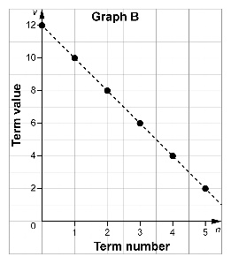

Observations/Documentation

