Comparing Proportional Situations
Compares proportional situations using ratio tables  Ben cycles 4 km in 12 min.  Lyn cycles 10 km in 25 min.  Who has the greater average speed?  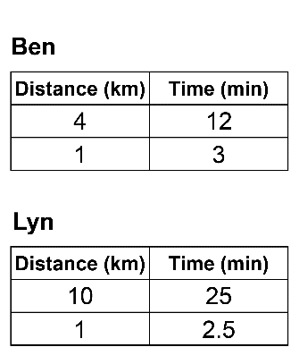  Lyn takes less time to travel 1 km,  so has the greater average speed. | Compares proportional situations using unit rates  Which is the better buy?  5 oranges for $2.99 or 8 oranges  for $4.88.  Unit rate for 5 oranges is:  $2.99 ÷ 5 = $0.598  Unit rate for 8 oranges is:  $4.88 ÷ 8 = $0.61  5 oranges is the better buy. | Identifies different strategies to solve the same proportion problem  Which is the better buy?  5 oranges for $2.99 or 8 oranges  for $4.88.  Scale up to determine the cost for  40 oranges.  5 oranges cost $2.99, so 40 oranges cost:  8 × $2.99 = $23.92  8 oranges cost $4.88, so 40 oranges cost:  5 × $4.88 = $24.40  5 oranges is the better buy. | Explains how different strategies for solving a comparison proportion problem are related  For the oranges, the costs for  40 oranges are also rates, but not unit rates. They are rates per  40 oranges.
Observations/Documentation

