Recognizing and Describing Proportional Situations
Recognizes and describes a proportional situation  Is this situation proportional?  Jack earns $7/h for babysitting.  “This is a proportional situation because if Jack works twice as long, they get paid twice as much.” | Represents a proportional situation in different ways  In a pattern, there are 6 black squares for every 3 white squares.  - “As a picture  - As a ratio table  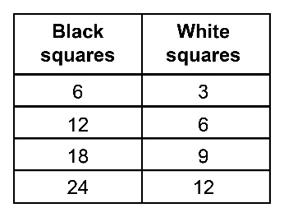  - As a unit rate  2 black squares/white square” | Identifies the scale factor for a proportional situation  On a scale diagram of a field, 5 cm represents 100 m.  “The scale factor for the diagram is:  $\frac{5}{10 000}$ = $\frac{1}{2000}$“ | Chooses a strategy to solve a proportion problem  In a rectangle, the ratio of the length to the width is 5:3.  The length is 20 cm.  What is the width?  “Make a ratio table.  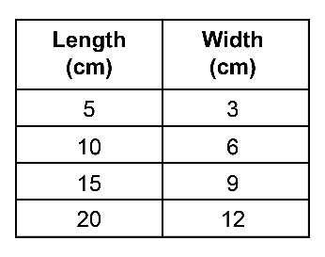  The width is 12 cm.”
Observations/Documentation

