Multiplying Fractions
Multiplies a fraction by a whole number or vice versa  3 × 3$\frac{3}{5}$  “I know this is equal to 3$\frac{3}{5}$+ 3$\frac{3}{5}$+ 3$\frac{3}{5}$,  which is the same as  (3 + 3 + 3) + ($\frac{3}{5}$+ $\frac{3}{5}$+ $\frac{3}{5}$)  = 9 + $\frac{9}{5}$  = 9 + 1$\frac{4}{5}$  = 10$\frac{4}{5}$  Because changing the order doesn’t change the product, I know that  3$\frac{3}{5}$× 3 = 10$\frac{4}{5}$ as well.” | Multiplies fractions and/or mixed numbers using a model  “To multiply $\frac{1}{3}$× 2$\frac{3}{4}$, I drew an array  showing 2$\frac{3}{4}$. Then, I partitioned it into  3 equal parts and shaded one part differently.  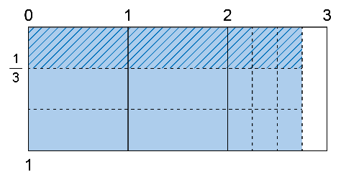  I rearranged the shaded pieces to compare them to 1 whole.  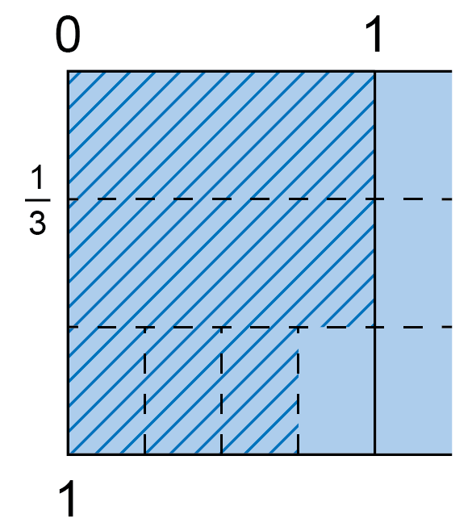  I can see that $\frac{11}{12}$ are shaded.  So, $\frac{1}{3}$× 2$\frac{3}{4}$= $\frac{11}{12}$.” | Multiplies fractions and/or mixed numbers symbolically  “To multiply $\frac{1}{3}$× 2$\frac{3}{4}$, I’m first going to  write the mixed number as an improper fraction. Then, I can just multiply the numerators and the denominators.  $\frac{1}{3}$× 2$\frac{3}{4}$= $\frac{1}{3}$× $\frac{11}{4}$  = $\frac{11}{12}$” | Solves problems that involve multiplying fractions and/or mixed numbers  “Toby has 32$\frac{1}{2}$yd of electrical cable.  They use $\frac{1}{5}$of the cable on a wiring  project. How many yards of cable are left?  Since Toby uses $\frac{1}{5}$of the cable,  I know that $\frac{4}{5}$remain.  $\frac{4}{5}$× 32$\frac{1}{2}$= $\frac{4}{5}$× $\frac{65}{2}$  = $\frac{260}{10}$  = 26  There are 26 yd of cable left.”

Observations/Documentation

