Dividing Integers
Interprets a given model of integer division  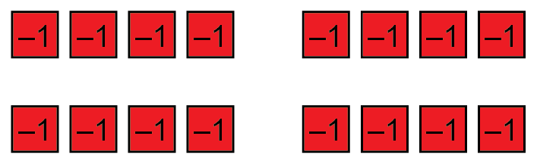  “Each red tile represents –1, so each group of red tiles represents –4. Altogether, the model represents  –16 and there are 4 groups of –4. So, this model shows the quotient  (–16) ÷ (–4) = +4.” | Divides integers by using a model  or inverse operations  “I want to determine (–10) ÷ (+2).  I know that (+2) × (–5) = (–10).  Since multiplication and division are inverse operations, I know this means that (–10) ÷ (+2) = (–5).  So, the quotient is –5. | Divides integers by using patterns and known relationships  “I know that when you divide a positive integer by a negative integer (or vice versa), the result is negative. When you divide a negative integer by another negative integer,  the quotient is positive.” | Uses integer division to solve problems  Given the division statement  (–48) ÷ __8 = __6, what signs would you put in the blanks to create the greatest possible quotient?  To create the least possible quotient?  “The greatest possible quotient is +6. Since the dividend is negative,  to get an answer of +6, the divisor should be negative as well:  (–48) ÷ (–8) = (+6).  The least possible quotient is –6. Since the dividend is negative,  to get an answer of –6, the divisor should be positive:  (–48) ÷ (+8) = (–6).”
Observations/Documentation

