Multiplying Integers
Interprets a given model of integer multiplication  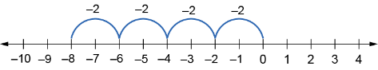  “Each hop represents –2.  Since there are 4 hops, this model shows the product +4 × (–2) = –8.” | Multiplies integers by creating  and using a model  “I can use algebra tiles to represent 2 × (–3).  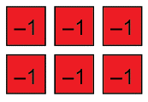  I know that (–2) × (–3) is the opposite of this, so I can model it  by flipping the tiles.  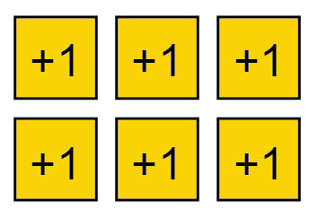  So, (–2) × (–3) = +6. | Multiplies integers by using  observed patterns  “I know that when you multiply a positive integer and a negative integer, the result is negative.  When you multiply two negative integers, the product is positive.” | Uses integer multiplication to model and solve a scenario  Every month, Dymtro debits $50 from their bank account to pay for their cell phone plan. They do this every month for 6 months.  How does this affect Dymtro’s bank balance in that time?  “I used a negative integer to represent this payment since money is being removed from the account. In 6 months, the change in the account balance for this expense is: 6 × (–$50), which is –$300.”
Observations/Documentation

