Adding and Subtracting Integers
Interprets a given model of integer addition or subtraction  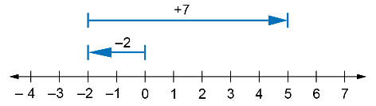  “The arrow to the left represents –2 and the arrow to the right represents +7. This model shows that  (–2) + (+7) = (+5).” | Adds or subtracts integers by creating and using a model  “I can use a number line to determine the sum 4 + (–6).  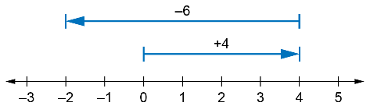  The sum is –2.” | Adds or subtract integers by using observed patterns  Find: –3 – (–5)  “I know that –3 – (–5) = –3 + 5  = 2” | Uses integer addition or subtraction to model and solve a scenario  An elevator travels up 5 floors from ground level, down 3 floors, and then up 8 floors. What floor does the elevator end up on?  “I used positive numbers to represent moving up, negative to represent moving down and 0 for the ground floor. The position of the elevator can be described as  (+5) + (–3) + (+8), which is equal to  5 – 3 + 8, or 10.  The elevator ends up on the  10th floor.”
Observations/Documentation

