Fraction Number Lines
Number
Unit 2 Line Master 8a

The following number lines have been partitioned into halves, thirds, fourths, fifths, and sixths.

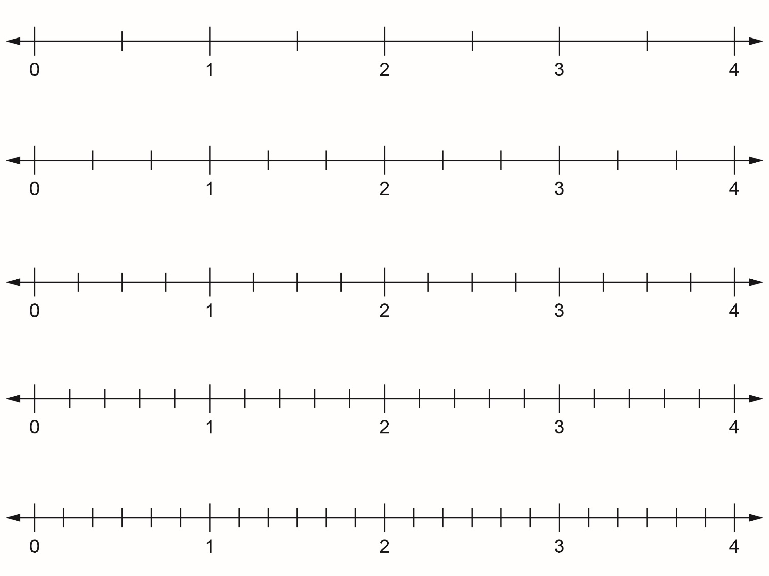

Fraction Number Lines (cont’d)
Number
Unit 2 Line Master 8b

The following number lines have been partitioned into sevenths, eighths, ninths, tenths, and twelfths.

